**Unit2..Appliance of Science** **3rd grade secondary**

**1- Choose the correct word under the pictures :**

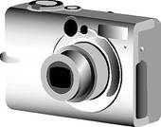

**a-( vacuum cleaner – washing machine ) b-( camcorder – digital camera )**

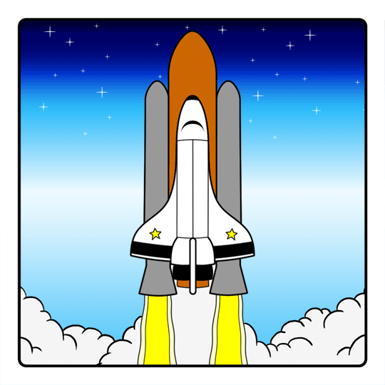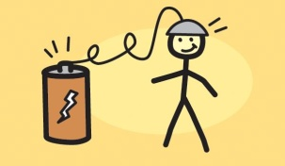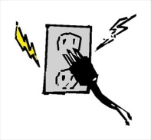

**c-( plug in – insert ) d-( recharge – switch on) e-( satnav - MP3 player) f-(spaceship-oil tanker)**

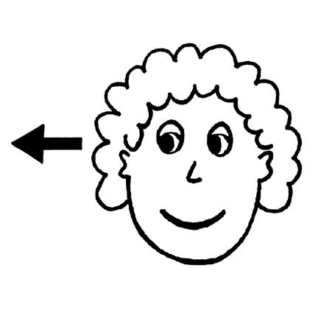2-

**Prepositional phrases with adjectives :**

Aware **of** – good **at** – different **from** – interested **in** – afraid **of** – worried **about**

**Fill in the space with the correct prepositions :**

a- Are you good -------------- science ?

b- Are you interested -------------- technology ?

c- Are you aware -------------- the latest stories in the news ?

d- Are you afraid ------------- flying ?

3-

**Have something done**

I have my hair cut

**Write complete sentences about the pictures using ( have something done ):**

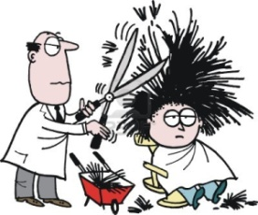

1- - ( He - his hair – cut) ---------------------------------------------



2- ( I – my dinner – cook ) --------------------------------------------

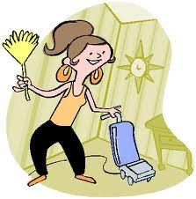

3- ( Samar – her room – clean ) --------------------------------------------

**4- Change into passive :**

a- The student baked a cake

-------------------------------------------------------------------------------------------------

b- Ali studies English and Math

-------------------------------------------------------------------------------------------------

c- Suzan had phoned the teacher

-------------------------------------------------------------------------------------------------

d- The student has won the races

-------------------------------------------------------------------------------------------------

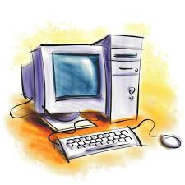

**5- Writing : “ The Computer is the most important invention ever “**

**Write an essay giving arguments for and against this statement and give**

**your own opinion :**

------------------------------------------------------------------------------------------------------------------------------------------------------------------------------------------------------------------------------------------------------------------------------------------------------------------------------------------------------------------------------------------------------------------------------------------------------------------------------------------------------------------------------------------------------------------------------------------------------------------------------------------------------------------------------------------------------------------------------------------------------------------------------------------------------------------------------------------------------------------------------------------------------------------------------------------------------------------------------------------------------------------------------------------------------------------------------------------------------------------------------------------------------------------------------------------------------------------------------------------------------------------------------------------------------------------------------------------------------------------------------------------------------------------------------------------------------------------------------------------------------------------------------------------------------------------------------------------------------------------------

**6-Write the name of the invention :**

a- Cook food very quickly without using heat -----------------------------

b- take photos ----------------------------------

c- wash plates , cups , knives and forks ------------------------

**Underline the linkers that introduce and order the arguments the writer used :**

In conclusion , television is not necessarily a bad thing but parents should be careful how much their children watch .In my opinion , good programs that are well made are fantastic but , on the other hand , they do prevent people from taking part in other activities and some of the output is unsuitable.

Prepared by

Teacher Bushra Assiri