**The Kingdom of Saudi Arabia**

**Ministry Of Education.**

**Name:……………. Class:……………**

**الصف الثاني المتوسط**

**English Written Mid Term Exam 1433-1434 H- 2nd Term -**

**10**

***Q1. Use the following words:***

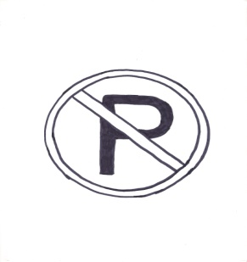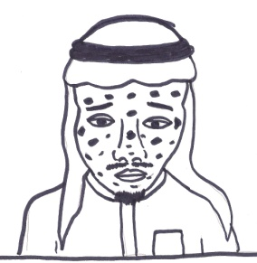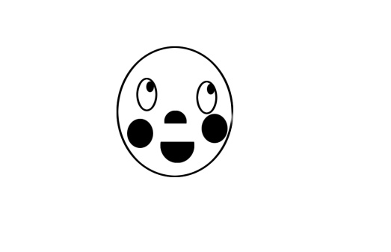

( a - y - o- u- i)

( a - y - o- u- i)

( a - y - o- u- i)

1. Don't p—rk 2. Sh-- 3. Chicken p—x

Q2:Answer the questions:

a. How high is Mamlaka Tower ?

{ 300 m long – 300 sq m. – 300 m high .}

b. What should you do when you are sick ? You should ……………………….

{go to the mechanic - see a doctor . - study hard . }

Q3: Choose ;

1.My writing is ( clear– clearly ) .

2. My report is the { good- better – best} .

3. Riyadh is very ( crowded – more crowded – most crowded ) .

4. ( Was- Were ) he in Makkah last week ?

5. Ali is ( in – over – on ) the class .