What 's a newspaper made of? 1-

……………………………………………………………………………………………….

Is all the climate change man-made?

…………………………………………………………………………………………………..

- **give the opposite**

Man-made x ………………………………….

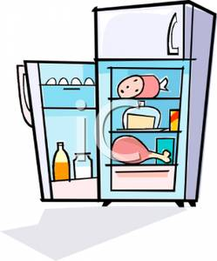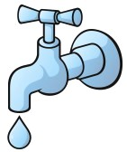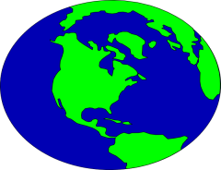**Write the suitable word under each picture**

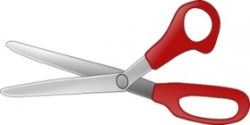

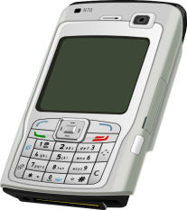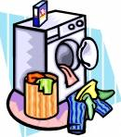

**What 's a bottle bank for?**

………………………………………………………………………………………………………………………………………………

**A) Choose**

1-Scissor are for ( **cut –cuts – cutting** ) paper. .

2-Fridge is for ( **keep – keeps- keeping** ) food cold. .

**B)Re arrange the following words**:

1-For- friend - mobile phones- talking – are – to- your

…………………………………………………………………………………………………………………………………………………………………………

2-look up – is – dictionary – words – for

…………………………………………………………………………………………………………………………………………………………………………

**Write the suitable word under each picture**

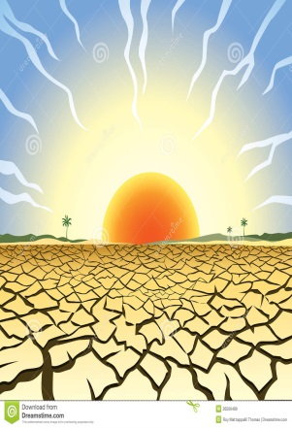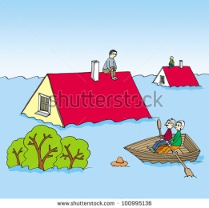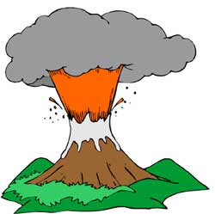

**Fill the missing words:-**

1-……………………… is too much water

2-…………….…………. is not enough water

**Give the opposite:-**

Floods ≠ ……………………………………