**Complete the following:-**

1-He is doing his homework,……………………….?

………………………………………………………………………

2- It is Italian,…………………………?

……………………………………………………………………..

3- They are hungry,…………………………?

…………………………………………………………………….

**Write the suitable words under each pictures:-:-**

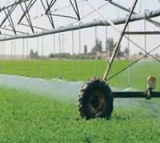

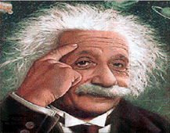**Write the suitable words under each pictures:-:**

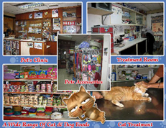

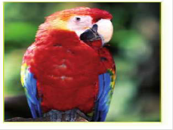

**Choose the correct words** :

1-(**Who – Whose – What** ) is the camera ? It's Fatimah's .

( Whose are the pens ? They're **( our – we – theirs** 2-.

( Whose is the cat ? It's **( Ahmad – Ahmad's – Ahmad is** 3- .

4-Whose **( am – is – are** ) the trousers ? They're his .

**Do as shown between the brackets:-**

1-He ( come ) …………………… from Egypt last week ( correct the verb) .

( correct the verb 2-They ( think ) ………………………. they were late .