Name: ...................................................................

Class: 1 / ..............

***Choose and complete:***

thanks

name's

old

What's

12

nice

How

I'm

**Salma**: Hi, I'm Salma. ............................ your name?

**Fatin** : My ........................ Fatin. It's ..................... to meet you, Salma.

................. are you?

**Salma**: I'm fine, ................................. How .................... are you?

**Fatin** : ................ 13. And you?

**Salma**: I'm ............

**************************************************************************************************************

***1- Choose :***

1. She [ am - is - are ] a student.
2. [ I - We - He ] is my father.
3. We [ am - is - are ] in the park.
4. [ she - They - It ] are from Saudi Arabia.
5. It's [ a - an - ᴓ ] apple.
6. ball.pngball.pngIt's [ a - an - ᴓ ] bus.
7. 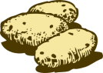They're two [ ball - balles - balls ].
8. They're three [ potato - potatoes - potatos ].

****************************************************************************************************

***Count and write:***

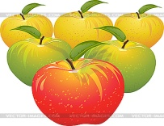

1- 2- 3-

....................................... .................................. ......................................