**Write the suitable word under each picture**

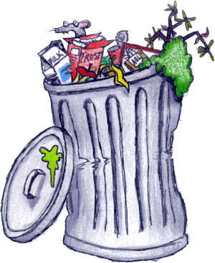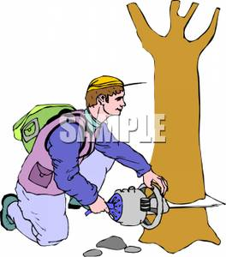

**Use ( much ) or (many ) with the following sentence:-**

a) we are using too ………………………..electricity .

b) we are driving too …………………….cars .

c) There is too……………………..carbon dioxide above the Earth.

**2- Choose the correct word:-**

a) We make too ( **many –much** ) paper .

b) There are too ( **many – much** ) planes in the world .

**Write the suitable word under each picture**

**Choose the correct answers:-**

1-They shouldn't ( **study- studying –studied** )in this place .

2- She should **( clean –cleaning – cleaned )** your room .

3-We should drive ( **fewer – less** ) cars.

4- W should use( **fewer – less** ) electricity

**write sentence with Should / shouldn't .use the following verb .**

1- He ………………………………..…..to bed.

2-They ………………………………………………….football near the house.

3-She………………………………very hot plates .

**Complete with less or fewer**

a) in the year 3000 there's going to be …………………….oil .

b) can we use ………………………..paper at school .

c) We should cut down………………………….trees.

d) I know ………………………..English words than my teacher .