**Write the suitable word under each picture**

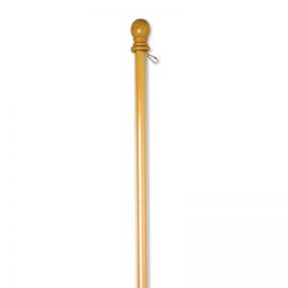

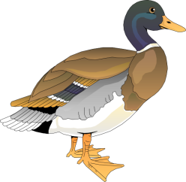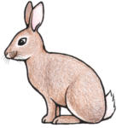

**Re arrange the following words**:

1-look –she –sister – likes – her .

………………………………………………………………………………………………………………………………..

2- looks- a tiger- it – like.

…………………………………………………………………………………………………………………………………….

**Put (T) or (F) in front of each sentences:-**

1- Stonehenge is a famous circle of stone ( ) .

2- Stonehenge is in western England ( ) .

3-Stonehenge is between 3,500 and 4,500 years old ( )

**Give the opposite:-**

east ≠………………………. agree ≠ …………………………… ancient ≠ ……………………..

**Write so …or neither with these sentences**

a) They aren't English

…………………………………………………………………………………………………………….

.

b) He loves cheese.

…………………………………………………………………………………………………………………

**Choose:-**

1-He may (**travel - travels**) by train. .

2-She may ( **go – goes** ) outside.

**Do as shown between brackets:-**

1-That's my horse. It is in the field **( join the sentences)** .

……………………………………………………………..

2-Who's the man? He's coming downstairs  **( join the sentences)**

………………………………………………………………………………………………..