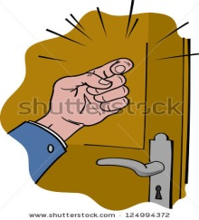**Write the suitable word under each picture:**

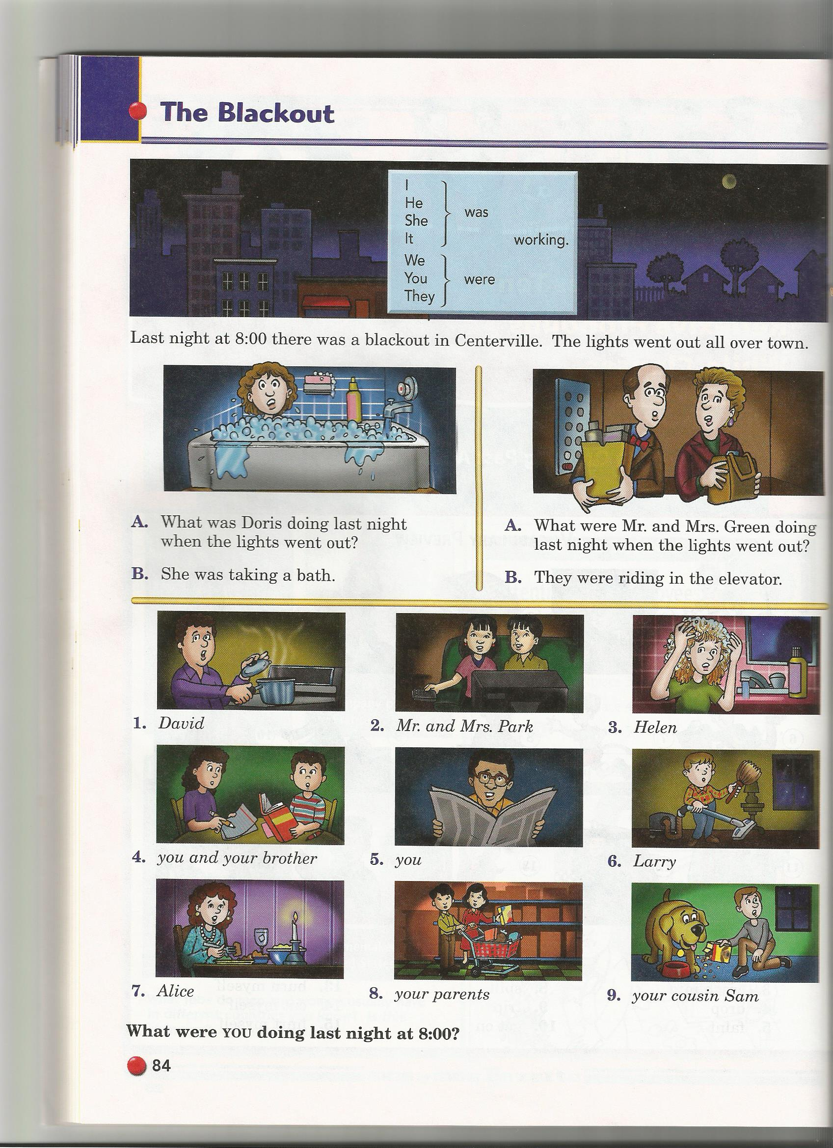

**Correct the verb:-**

a) At five o'clock they were ( watch ) the TV

………………………………………………………………………………………………………………………………………

b) last night at nine o'clock he was (play ) football.

………………………………………………………………………………………………………………………………………

**Choose the correct answer:-**

a) She was ( **cook – cooked – cooking** ) Kabsa .

b) They were ( **Study – Studied - Studying** ). ) .

c) At six o'clock in the morning I was **( had – have – having )** my breakfast. .

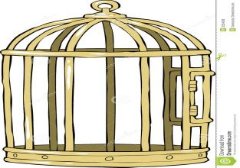**What is this?**

…………………………………………..

**Choose the right answer:-**

a) She could ( **cleaning – clean- cleans** ) the room alone .

b) They could ( **win – won – wining** ) tomorrow.

**Change in to negative:-**

a) She could drive the car .

…………………………………………………………………….

b) I could travel alone .

……………………………………………………………………….

**Make yes |No question from the following:-**

a) She could clean her room .

……………………………………………………………..

b) They could answer the question .

…………………………………………………………………