**Revision Unit 2.. Big moments** 2nd grade secondary

**1- Choose the write word under the pictures :**

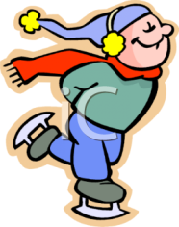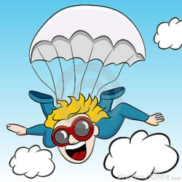

a- ( bowling – surfing ) b-( parachuting – bungee jumping ) c-( surfing- ice skating)



d-( relaxed – dizzy ) e- ( terrified – happy ) d-( excited – nervous )

2-

**Obligation and necessity freedom**

Have to# don’t have to you can

Need to# don’t need to you don’t need to

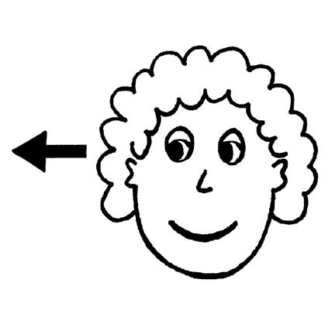

**Choose the correct answers :**

a- We need **( to leave – leave )** now

b- Muslims **( have to – need to )** pray five times a day

c- Children **( have to – need to )** attend school , it’s the law

d- The cake is tasty , but I think you **( need to – have to )** add some sugar.

3-

Preposition + present participle time expressing

( since – after – before – while ) + ( v- ing )

**Correct the verb :**

a- Since ----------------------**( leave )** school today , I had a nice surprise

b- After ------------------------ **( say )** goodbye to him, I continued on my way to home .

**4- Write the words under the correct category :**

( ceremony – graduate – groom – engagement – reception – scholarship- best man – diploma )

**Wedding** : ------------------------------------------------------------------------------------------------------------------------------------------------------------------------

**Graduation** : ----------------------------------------------------------------------------------------------------------------------------------------------------------------------

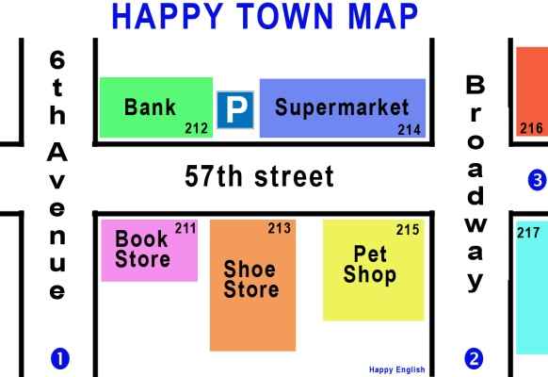**5- give directions to get from point 1 to 2:**

----------------------------------------------------------------

----------------------------------------------------------------

----------------------------------------------------------------

----------------------------------------------------------------

----------------------------------------------------------------

http://www.getdownintwo.com/wp-content/uploads/2013/06/2-graphic.pnghttp://www.andlil.com/wp-content/uploads/2013/04/R%C3%A8gle-1.png----------------------------------------------------------------

**6- Sara is introducing herself formally , put ( ) or ( X ) next to the phrases :**

a- Hi , everyone , this is sara. ( )

b- Good evening , I am Sara Alajmi .( )

c- Hi , I am Sara, how are you ? ( )

d- Hello , I am Sara Alajmi , Nice to meet you . ( )

**7- Sami is going to make interview , put ( ) or ( X ) to the following behaviors during the interview:**

a- dress smartly . ( )

b- speak clearly and confidently . ( )

c- tell the interviewer how great student you are , even if it is not true . ( )

d- No problem if you arrived late . ( )

Prepared by

Teacher..Bushra Assiri