Name/ class / 3 -

**1-Read then answer the following questions:**

While he was growing up, Jamie Oliver's parents ran a restaurant in England and he used to practice cooking there. He enjoyed cooking very much , so after he finished school , he went to Westminster Catering College , where he studied to become a chef.In 1999, he started working in the River Café, That's where the BBC noticed him . He wrote a cookbook which became a best-seller. In the same year he received an invitation to prepare lunch for the Prime Minister at 10 Downing Street . In 2005 Oliver introduce a campaign to improve school dinner in the UK . Oliver's next campaign was to get people of the USA to start eating healthy , and he started off with West Virginia . He wants to inform communities about how important it is to eat home- made healthy food .Hopefully his message will spread across the world .

***1- When did he start working ?***

***…………………………………………………………………………………………………………***

***2- What did he write ?***

**3) Did he enjoy cooking ?**

***…………………………………………………………………………………………………………..***

***4-) Put ( T ) or ( F ) :***

a- In 2003 Oliver introduce a campaign to improve school dinner in the UK ( ).

b- He wants to inform communities about how important it is to eat home- made healthy food ( )

c-He Started working on TV cooking show. ( )

***___________________________________________***

***Match :-***

1-monthly ……..make

2-produce ……… lasting for month

3-Count me in ……… I don't think so

4-I doubt it ………. include me

**Match the correct word with pictures : B-**

  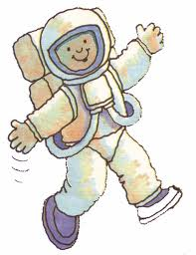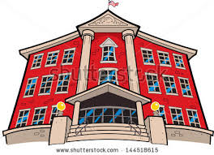

 

**A-Complete with all, none, neither , either, both :-**

1. My friends are coming round tonight. They are ………………. bringing some food.

2. Jack has 200 books, but ………………….. of them is about politics.

3. Omar and his brother are from Jeddah. …………………… of them are from Riyadh.

4-……………….Picasso and Van Gogh lived in France.

5- There are many tall students in my class , but ………………….of them are as tall as Ameen

6-Ihave five cousins and ………………………of them are university students

**B –Choose the correct answer:-**

1- we ( visited – have visited ) many interesting sights so far.

2- We ( have watched – watched ) it Yesterday.

_______________________________________

**c) Form nouns of these verbs by adding** ( -ion , -ation , -ment )

1- improve …………………. 2- creat……………. 3- organize ………………

4- collect…………………

Good luck

2- astronaut 3- bridge 4-get rid of 1-university

**1.** work