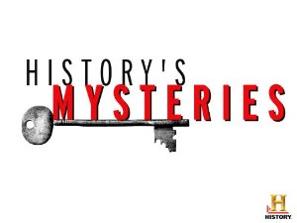**Revision Unit 5..** 3rd grade secondary

**1- Choose the correct word under the pictures :**

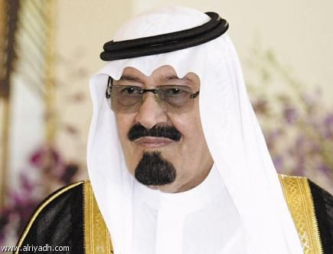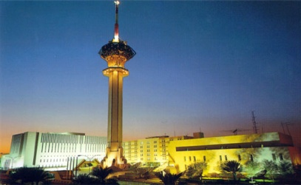

a-( capital city – country ) b-( currency- national anthem ) c-( king – prince )

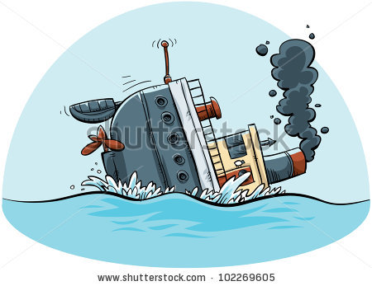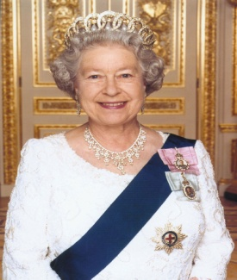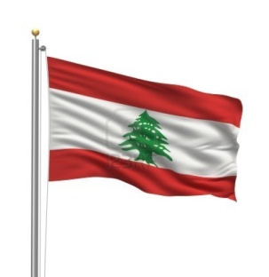

d-( president – flag ) e-( prime minister – queen ) f- ( iceberg – sink )

**2- Fill in the spaces with the correct words :**

**Constitutional monarchy – democracy – monarchy - republic**

a- A country that is ruled by a president not by a king is -------------------------------------------

b- ---------------------is a system of government where people vote to choose who will govern them

c- ------------------- is a type of government where a country is ruled by a king

3-

**Modal verbs of speculation and deduction – present**

**Must** 90% true

**Can’t** 90% not true

**May – might – could** 50 % true or not

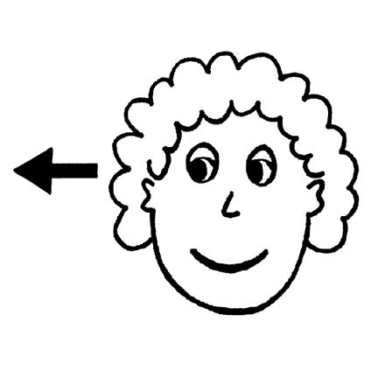

**Choose the correct answers :**

a- It **( must – can’t )** be snowing , it ‘s summer .

b- The history book **( can’t – must )** be yours because I‘ve got mine .

c- That **(could – must )** be 50% true.

4-

**Modal verbs of speculation and deduction – past**

Modal verb – have + 3rd (v)

**Choose the correct answers :**

a- The real prince may have **( die – died ) .**

b- She might **( have gone – had done )** last night .

c- You must **( have done – have did )** it .

5-

**Adjective suffixes :**

Noun + suffix adjective

**Correct the adjectives between brackets :**

a- This sofa is ---------------------------- **( comfort )**

b- I need a cup of water , I am ---------------------------------- **( thirst )**

c- He is very ---------------------- **( sense )** to leave the country

d- Sami is ------------------------ **( care )** about choosing his career .

6-

**Third conditional** : we use it for imaginary situation in the present or in the past

**If + had + 3rd ( v ) , would have 3rd (v )**

**If** you **had** **visited** me last night , we **would** **have finished** the school project



**Correct the verb between brackets :**

a- If the Roman empire ------------------------- **( continue )** , Latin would probably have remained

the most universal language .

b-If Christopher Columbus had sailed east , he ------------------------------------- **( not find out )**

that America existed .

c- If you had studied harder , you -------------------------- **( pass )** the test.

d- If the titanic ------------------------- **( not hit )** an iceberg , It wouldn’t have sunk.

**7- Composition : answer the following questions to write an essay about the ( Titanic ) :**

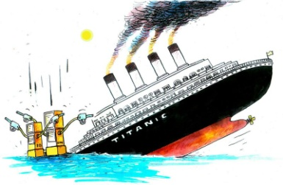What kind of story is it ?

How many people were travelling on the Titanic when it sank ?

How many lifeboats were there ?

Who decided the number of the life boats ?

What happened to the Titanic , and why ?

----------------------------------------------------------------------------------------------------------------------------------------------------------------------------------------------------------------------------------------------------------------------------------------------------------------------------------------------------------------------------------------------------------------------------------------------------------------------------------------------------------------------------------------------------------------------------------------------------------------------------------------------------------------------------------------------------------------------------------------------------------------------------------------------------------------------------------------------------------------------------------------------------------------------------------------------------------------------------------------------------------------------------------------------------------------------------------------------------------------------------------------------------------------------------------------------------------------------------------------------------------------------------------------------------------------------------------------------------------------------------------------------------------------------------------------------------------------------------------------------------------------------------------------------------------------------------------------------------

----------------------------------------------------------------------------------------------------------------------------------------------------------------------------------------------------------------------------

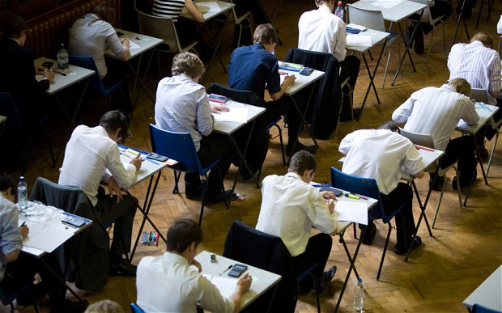**8- Writing :** Describe the following photo

Say what you think is happening Have you ever

seen or been in situation like the One in the

picture ? when ? what happened ?

Use expressions of speculations and

deductions :

--------------------------------------------------------------------------------------------------------------------------------------------------------------------------------------------------------------------------------------------------------------------------------------------------------------------------------------------------------------------------------------------------------------------------------------------------------------------------------------------------------------------------------------------------------------------------------------------------------------------------------------------------------------------------------------------------------------------------------------------------------------------------------------------------------------------------------------------------------------------------------------------------------------------------------------------------------------------------------------------------------------------------------------------------------------------------------------------------------------------------------------------------------------------------------------------------------------------------------------------------------------------------------------------------------------------------------------------------------------------------------------------------------------------------------------------------------------------------------------

Prepared by

Teacher. Bushra Assiri