







**Name:**

**.....................**

**Unit: 1**

**Lesson: 1**

**Classroom:**

**.....................**

**Activity:**

**....................**

**English working paper**



***Which of the trips or vacations would you prefer and why?***

____________________________________________________________________________________________________________________________________________________________________________________________________________________________________________________________

***Which of them would you definitely not be interested in? Why?***

____________________________________________________________________________________________________________________________________________________________________________________________________________________________________________________________

***Match the words with their definitions.***

|  |  |
| --- | --- |
| **1. wrecking**  **2. cater to**  **3. purchase**  **4. complimentary**  **5. certified**  **6. mandatory** | 1. **having official qualifications** 2. **free of charge** 3. **buy** 4. **obligatory** 5. **destroying** 6. **provide services to** |









**Name:**

**.....................**

**Unit: 1**

**Lesson: 2**

**Classroom:**

**.....................**

**Activity:**

**....................**

**English working paper**



1. **The captain promised the passengers that the ship would ------------------- the port in time to go ashore for lunch.**
2. **What is the best way to -------------------to your uncle’s ranch?**
3. **As we -------------------the city centre, the traffic got really heavy.**
4. **Are you -------------------to the airport with us to meet Dennis? His plane is scheduled to -------------------at 18:30.**

**arrive - get - reach - come - approach**

Complete the sentences using the correct form of the words.

***The following groups of verbs express states - not actions - and are not used in progressive tenses.*** ***Add two verbs to each group.***

* **Verbs of the senses (see, hear, feel, etc.) (----------------, -------------------)**
* **Verbs of emotions and preferences (like, hate, want, prefer, etc.)**

**(----------------, -------------------)**

* **Verbs of perception, belief and knowledge (know, believe, remember, etc.) (----------------, -------------------)**
* **Verbs of ownership (have, possess, etc.) (----------------, -------------------)**
* **Other verbs which describe permanent states (be, cost, seem, etc.)**

**(----------------, -------------------)**









**Name:**

**.....................**

**Unit: 1**

**Lesson: 3**

**Classroom:**

**.....................**

**Activity:**

**....................**

**English working paper**





1. **I am looking for some *information / informations* son endangered species for a project I have to do.**
2. **There were only *few / a few* people at Jim’s house last night, but we had a great time.**
3. **I’ve got *hardly any / a little* money left, so I have to go to the bank and get some.**
4. **A: Did you like the documentary?**
5. **B: Yes, I liked it *lots / a lot*.**
6. **Your new furniture *is / are* really stylish.**
7. **I don’t have *much / many* time left. I need to leave for the airport soon.**
8. **There *are / is* not enough natural *light / lights* coming into the room.**
9. **This job requires previous work *experiences / experience.***
10. **There has been very *little / few* rain lately.**
11. **People say that no news *is / are* good news.**

Read the sentences and circle the correct answer.









**Name:**

**.....................**

**Unit: 1**

**Lesson: 4**

**Classroom:**

**.....................**

**Activity:**

**....................**

**English working paper**



**In summer, people everywhere (1) ----------------- forward to their holidays when they will have the chance to relax and escape the daily routine and pressure at work. However, things don’t always work (2) -----------------well and the dream can actually turn (3) -----------------a nightmare. Well, here are a (4) -----------------tips that will help you enjoy your holiday. To begin with, (5) -----------------only should you choose a holiday destination (6) -----------------suits your needs, but also go along with someone with whom you share common interests and are on good terms with, so as to avoid arguments. Secondly, (7) -----------------sure you have made a hotel reservation well in advance to spare yourself the trouble (8) -----------------finding suitable accommodation at the last minute, especially during the high season. Last but not least, make a list of (9) -----------------you need to take with you, especially those things you know you won’t be (10) --------------to find at the place where you (11) -----------------heading to. Then, don’t forget to go shopping a couple of days before you actually leave. If you allow yourself (12) -----------------of time to do some planning beforehand, nothing will spoil your holiday.**

***Read the text below and complete the gaps. Use only one word in each gap.***









**Name:**

**.....................**

**Unit: 1**

**Lesson: 5**

**Classroom:**

**.....................**

**Activity:**

**....................**

**English working paper**



write an appropriate response for each prompt.

**Would you like to go fishing next weekend?**

**Sorry but …**

**Do you think you could come and visit me in June instead of July?**

**June, fine …**

**Would you rather spend a long weekend in London or in a village in Wales?**

**Say which and why …**









**Name:**

**.....................**

**Unit: 2**

**Lesson: 1**

**Classroom:**

**.....................**

**Activity:**

**....................**

**English working paper**



***Match the words with their definitions.***

|  |  |
| --- | --- |
| **1. stand out**  **2. made up**  **3. turned out**  **4. made up for** | 1. **to form** 2. **to compensate for** 3. **to be very noticeable** 4. **to happen in a particular way** |

***How is the place you come from different from Iceland?***

**____________________________________________________________________________________________________________________________________________________________________________________________________________________________________________________________________________________________________________________________________**









**Name:**

**.....................**

**Unit: 2**

**Lesson: 2**

**Classroom:**

**.....................**

**Activity:**

**....................**

**English working paper**



Complete the sentences using the words in the box.

**1. Jeremy didn’t come to the meeting, and the manager commented on his -------------------------.**

**2. If it doesn’t rain in spring, there will be a(n) -----------------------of water this summer.**

**3. Maria reported the ---------------- of her passport to the police.**

**4. Amanda was given the job in spite of her ----------------------- of experience.**

**absence - lack - shortage - loss**

Complete the blanks with the verbs (make) or (do).

**6. ----------------a fuss**

**7. ----------------one’s duty**

**8. ----------------good/harm**

**9. ----------------up one’s mind**

**10. ----------------sense**

**1. ---------------- an effort**

**2. ----------------a purchase**

**3. ----------------business**

**4. ----------------certain/sure**

**5. ----------------a complaint**









**Name:**

**.....................**

**Unit: 2**

**Lesson: 3**

**Classroom:**

**.....................**

**Activity:**

**....................**

**English working paper**



***Complete the sentences below with the correct form of the words in capitals.***

**IMPRESS**

**1. My older sister has an ----------------------- collection of coins.**

**OVERWHELM**

**2. The sight of the burnt countryside filled me with an --------------------------------- feeling of sadness.**

**THRILL**

**3. The famous artist said that he was ----------------------- to visit his hometown.**

**SCARE**

**4. When I saw the bear coming towards me, I was too ------------------to move.**

***Read the text and complete the blanks with [a, an, the or -].***

**(1) ----------- Museum of (2) ----------- Modern Art in New York is (3) ----------- great museum. Not only does it contain beautiful paintings by (4) ----------- famous artists, such as Monet and Picasso, but (5) ----------- building itself is also (6) ----------- excellent work of (7) ---------- architecture.**









**Name:**

**.....................**

**Unit: 2**

**Lesson: 4**

**Classroom:**

**.....................**

**Activity:**

**....................**

**English working paper**



**Where do you live? What do you like or dislike about the area?**

**_____________________________________________________________________________________________________________________________________________________________________________________________________________________________________________________________________________________________________________________________________________________________________________________**

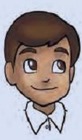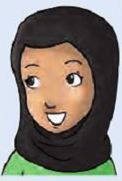









**Name:**

**.....................**

**Unit: 2**

**Lesson: 5**

**Classroom:**

**.....................**

**Activity:**

**....................**

**English working paper**



**Read the rubric below and write the article (120-180 words).**

**You have seen this announcement in an international travel magazine.**

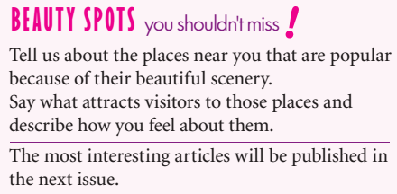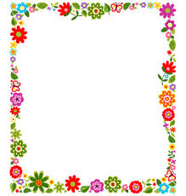

__________________________________________________________________________________________________________________________________________________________________________________________________________________________________________________________________________________________________________________________________________________________________________________________________________________________________________________________________________________________________________________________________________________________________________________________________________________________________________________________________________________________________________________________________________________________________________________________________________________________________________________________________________________________________________________________________________________________









**Name:**

**.....................**

**Unit: 3**

**Lesson: 1**

**Classroom:**

**.....................**

**Activity:**

**....................**

**English working paper**



Match the phrasal verbs with their meanings.

**1. break into**

**2. make off**

**3. hold up**

**4. go through with**

**5. pick out**

**a. to do something despite the difficulties**

**b. to choose**

**c. to leave quickly**

**d. to rob**

**e. to enter by force**

**A thief attempted to break into what he thought was a deserted car...------------------------------------------------------------------------------------------------------------------------------------------------------------------------------------------------------------------------------------------------------------------------------------------------------------------------------------------------------------------------------------------------------------------------------------------------------------------------------------------------------------------------------------------------------------------------------------------------------------------------------------------------------------------------------------------------------------------------------------------------------------------------------------------------------------------------------------------------------------------------------------------------------------------------------**

Make up your own funny crime story using the following opener.









**Name:**

**.....................**

**Unit: 3**

**Lesson: 2**

**Classroom:**

**.....................**

**Activity:**

**....................**

**English working paper**



***Match the verbs with the words/phrases to form collocations connected with crime and punishment.***

1. **pay**
2. **commit**
3. **serve**
4. **plead**
5. **break**
6. **take**
7. **reach**
8. **the law**
9. **a verdict**
10. **to court**
11. **time**
12. **a fine**
13. **a crime**
14. **guilty**

***Complete the text with the Past Simple or the Past Progressive of the verbs in brackets.***

**Yesterday morning, there (1)---------------- (be) an attempted robbery at a computer shop. Two men who (2) ---------------- (wear) gorilla masks (3) ---------------- (run) into the shop, (4) ---------------- (pull) out their guns and (5) ---------------- (ask) for all the money in the till.**









**Name:**

**.....................**

**Unit: 3**

**Lesson: 3**

**Classroom:**

**.....................**

**Activity:**

**....................**

**English working paper**



***Complete the sentences using the correct form of the words in capitals.***

**LOGICAL**

1. **It was ---------------------- to spend so much on a pair of shoes that were so uncomfortable.**

**CARE**

1. **The forest fire was started by a ---------------------- group of teenagers who lit a camp fire in the night.**

**EFFICIENT**

1. **This heating system is very ---------------------- because it uses lots of energy without heating up the room quickly.**

**HELP**

1. **Alice felt ---------------------- because she couldn’t rescue the injured bird.**

***Complete the second sentence so that it has a similar meaning to the first sentence, using the word given.***

**1- The exam was less difficult than I expected.**

**not**

**The exam --------------------------------------------------------------------.**

**2- My headache kept getting worse, so I took an aspirin.**

**and**

**My headache was getting ----------------------------------------------------------------------------------------------------------------------------------.**

**3- Yesterday it was a little cooler than it is today.**

**slightly**

**Today it is -------------------------------------------------------------------.**









**Name:**

**.....................**

**Unit: 3**

**Lesson: 4**

**Classroom:**

**.....................**

**Activity:**

**....................**

**English working paper**



**Read the text below and complete the gaps. Use only one word in each gap.**

**Frank Abagnale is a former fraud artist, who was (1) -------------------- to cheat banks (2) -------------- 26 countries out of 2.5 million dollars! He (3) ------born in New York in 1948 and, by the time he was nineteen, he (4) -------------------- pretended to be a doctor, a pilot, a teacher and even a lawyer.**

**During his time (5) ------- a ‘doctor’, which lasted only ten days, he (6) ------- able to perform minor duties by letting the medical students handle (7) -------------- of the cases. Pretending to be an airline**

**, (8) ------------------ he flew over 1,000,000 miles on over 250 flights to 26 countries, and he (9) -------------------- fly, eat and sleep for free. All this before he was even eighteen years old.**











**Name:**

**.....................**

**Unit: 3**

**Lesson: 5**

**Classroom:**

**.....................**

**Activity:**

**....................**

**English working paper**



What examples of vandalism can you think of?

**______________________________________________________________________________________________________________________________________________________________________________________________________________________________________________________________________________________________________________________________________________________**

What do you think causes vandalism?

**_________________________________________________________________________________________________________________________________________________________________________________________________________________________________________________________________________________________________________________________________________________________________________________________________________________________________________________________________________________________________________________________________**









**Name:**

**.....................**

**Unit: 4**

**Lesson: 1**

**Classroom:**

**.....................**

**Activity:**

**....................**

**English working paper**



***If you were to undertake a journey through the African wilderness, what sort of difficulties do you think you would encounter?***

**________________________________________________________________________________________________________________________________________________________________________________________________________________________________________________________________________________________________________________________________________________________________________________________________________________________________________________________**



***Why do you think the search for hidden treasure is a popular theme in many books?***

_____________________________________________________________________________________________________________________________________________________________________________________________________________________________________________________________________________________________________________________________________________________________________________________________________________________________________________________________________________________________________









**Name:**

**.....................**

**Unit: 4**

**Lesson: 2**

**Classroom:**

**.....................**

**Activity:**

**....................**

**English working paper**



**Replace the strong adjectives in sentences with very/extremely and the adjectives in the box.**

**1. Emad was furious when he discovered that Alex had borrowed his new car without his permission. (-------------------------------------------)**

**2. Kevin owns an enormous house in the countryside with more than twenty rooms. (-------------------------------------------)**

**3. Everybody started laughing when Luke walked in wearing a ridiculous hat.**

**(-------------------------------------------)**

**4. It is essential that you wear safety glasses when doing this experiment.**

**(-------------------------------------------)**

**5. I saw tiny insects crawling all over the walls of the building. (-------------------------------------------)**

**6. Layla made a delicious chicken pie last night. (-----------------------------------------)**

**7. Our hotel bathroom was disgusting; it was dirty and there were cockroaches crawling all over the floor. (-------------------------------------------)**

**8. That book was awful; the plot was stupid and the ending was very bad.**

**(-------------------------------------------)**

**9. I studied Archaeology because I find it fascinating. (-----------------------------------)**

**10. Nadia was terrified when she went bungee jumping. (--------------------------------)**

**angry - scared - small - big - bad - silly - interesting - tasty – unpleasant - important**

**Complete the text below with the Past Simple, Past Progressive,**

**Past Perfect Simple, Past Perfect Progressive or would + base form of the verbs in brackets.**

**My classmates and I (1) -------------------- (have) a wonderful winter holiday last year. As it (2) -------------------- (be) our last year at school, we (3) -------------------- (agree) earlier on in the year that we -------------------- (4) (all / go) somewhere together. We (5) ------------------------------------------ (study) really hard for the past few years, so everyone (6) -------------------- (want) a little adventure in their life.**









**Name:**

**.....................**

**Unit: 4**

**Lesson: 3**

**Classroom:**

**.....................**

**Activity:**

**....................**

**English working paper**



***Complete the sentences using the correct form of the words in the boxes.***

1. **The 2008 Olympic Games ------------------------in Beijing.**
2. **Are you going to ------------------------in the drawing competition?**
3. **Be careful! Do you really know how to ------------------------the car engine?**

**take part - take apart - take place**

***Match the questions with the answers.***

|  |  |
| --- | --- |
| 1. **Which documentary did Rayan say we should see? ( )** 2. **Who do I give the money to? ( )** 3. **What did you say? ( )** 4. **Who was on the phone just now?( )** 5. **Who did Lubna invite to her house? ( )** 6. **Who do you want to buy the dress for? ( )** 7. **Which of these pens is yours? ( )** 8. **What caused the accident? ( )** | * 1. **Give it to me.**   2. **The slippery road.**   3. **I said, ‘Don’t stay up too late.’**   4. **James. He will call back later.**   5. **All her friends, I think.**   6. **The life of birds. He says it’s great.**   7. **It’s for my daughter actually.**   8. **The yellow one.** |









**Name:**

**.....................**

**Unit: 4**

**Lesson: 4**

**Classroom:**

**.....................**

**Activity:**

**....................**

**English working paper**



**Discuss the following questions.**

**You can use some of the words/phrases in the box.**

**mobile phone - computer - game console - fridge - patience – optimism - strength - endurance - boredom - new experiences - test themselves**

1. **Which items that you use every day would you find difficult to live without?**
2. **What qualities should you possess to survive on a desert island?**
3. **Why do you think more and more people are in search of adventure nowadays?**

**______________________________________________________________________________________________________________________________________________________________________________________________________________________________________________________________________________________________________________________________________________________________________________________________________________________________________________________________________________________________________________________________________________________________________________________________________________________________________________________________________________________________________________________________________________________________________________________________________________________________________________________________________________________________________________________________________________________________________________________________________________________________________________________**









**Name:**

**.....................**

**Unit: 4**

**Lesson: 5**

**Classroom:**

**.....................**

**Activity:**

**....................**

**English working paper**



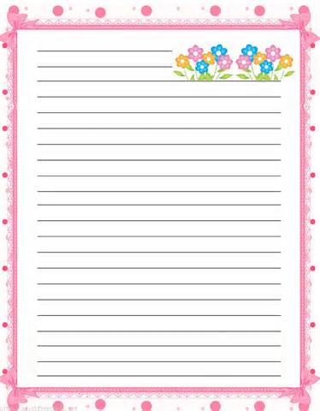

________________________________________________________________________________________________________________________________________________________________________________________________________________________________________________________________________________________________________________________________________________________________________________________________________________________________________________________________________________________________________________________________________________________________________________________________________________________________________________

________________________________________________________________________________________________________________________________________________________________________________________________________________________________________________________________________________________________________________________________________________________________________________________________________________________________________________________________________________________________________________________________________________________________________________________________________________________________________________

***Write a story (120-180 words).begin with the following words:***

***Michael didn’t really like adventure but that day he had no choice.***









**Name:**

**.....................**

**Unit: 5**

**Lesson: 1**

**Classroom:**

**.....................**

**Activity:**

**....................**

**English working paper**



***What are the advantages and disadvantages of working or studying at home?***

________________________________________________________________________________________________________________________________________________________________________________________________________________________________________________________________________________________________________________________________________________________________________________________________________________________________________________



***Match the definitions of the following words.***

**1. extent**

**2. undergo**

**3. radical**

**4. residential**

**5. drawback**

**6. commute**

1. **travel regularly**
2. **extreme**
3. **disadvantage**
4. **having private houses**
5. **size**
6. **go through**









**Name:**

**.....................**

**Unit: 5**

**Lesson: 2**

**Classroom:**

**.....................**

**Activity:**

**....................**

**English working paper**



***Use the correct form of the words in the boxes to complete the sentences***

1. **Abdul has bought a ------------------- in the countryside.**
2. **I want to stop and get some dinner before we go -----------------.**
3. **Where is the location of your -------------------, sir?**
4. **I believe wild animals should live in their natural ---------------- not in zoos.**

**habitat - home - house - residence**

***Read the dialogues and circle the correct words.***

**1. A: Where *are you going / do you go* on holiday next summer?**

**B: I *will probably go / ’m about to go* to Cyprus.**

**2. A: *Will you move / Do you move* house soon?**

**B: Yes, I *move / will move* as soon as they *finish / will finish* painting the house.**

**3. A: By one o’clock I *will drive / will have been driving* for four hours.**

**B: You should have a break. Let’s stop at a restaurant and have some lunch.**

**4. A: This time tomorrow we *will have flown***

***/ will be flying* to Paris.**

**B: Yes, I know. It’s so exciting!**









**Name:**

**.....................**

**Unit: 5**

**Lesson: 3**

**Classroom:**

**.....................**

**Activity:**

**....................**

**English working paper**



**Read the texts below. Underline and number the words/phrases in American English. What are their British English equivalents?**



|  |  |
| --- | --- |
| **Last week I did the stupidest thing... I lost my cell phone! It was a nice day, so I decided to walk home from work, rather than take the subway. I was almost home, when I realized that my phone was gone. I went to a gas station to use the pay phone, and I called my cell phone to see if someone would answer. A man picked up the phone! He said he had found my phone on the sidewalk in front of the local drugstore. Lucky for me, I guess. Anyway, I’m going to be more careful from now on!** | **------------------------------------------------------------------------------------------------------------------------------------------------------------------------------------------------------------------------------------------------------------------------------------------------** |

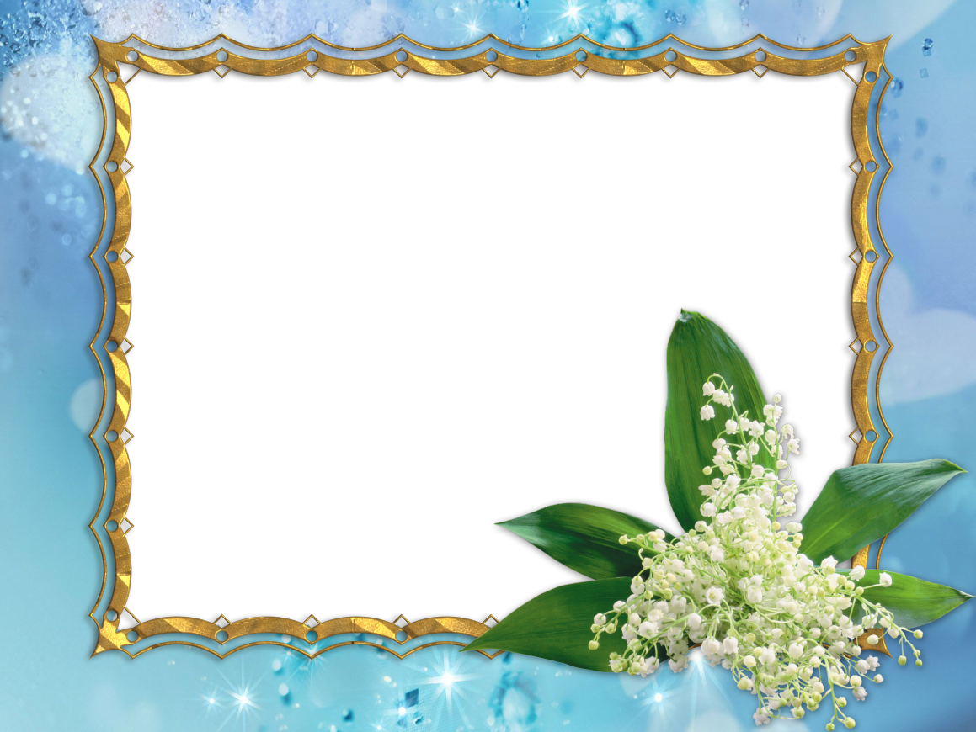

**Read the sentences and circle the correct answer.**

**1- *Must / May* I interrupt you?**

**‘Sure.’**

**2- They *should / might* make their reservations soon; otherwise the hotel will be full.**

**3- I’ve got really bad toothache.’**

**‘You *should / need* go to the dentist.’**









**Name:**

**.....................**

**Unit: 5**

**Lesson: 4**

**Classroom:**

**.....................**

**Activity:**

**....................**

**English working paper**





***Why do you think many people prefer to drive to school/work rather than use public transportation?***

**___________________________________________________________________________________________________________________________________________________________________________________________________________________________________________________________________________________________________________________________________________________________________________________________________________________________________________________________________________________________________________________________________________________________**

**Is it possible to have a form of transportation that is not harmful to the environment?**

**______________________________________________________________________________________________________________________________________________________________________________________________________________________________________________________________________________________________________**









**Name:**

**.....................**

**Unit: 5**

**Lesson: 5**

**Classroom:**

**.....................**

**Activity:**

**....................**

**English working paper**



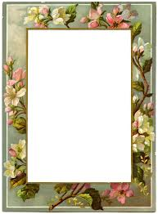

***Do you think that your lifestyle is as healthy as it should be? Why*** ***/ Why not?***

**______________________________________________________________________________________________________________________________________________________________________________________________________________________________________________________________________________________________________________________________________________________________________________________________________________________________**

***What things would you change in your life if you wanted to have a healthier lifestyle?***

**__________________________________________________________________________________________________________________________________________________________________________________________________________________________________________________________________________________________________________________________________________________________________________________________________________________________**









**Name:**

**.....................**

**Unit: 6**

**Lesson: 1**

**Classroom:**

**.....................**

**Activity:**

**....................**

**English working paper**



|  |
| --- |
| 1. ***Match the words with their meanings.*** |

|  |  |
| --- | --- |
| **a.home**  **b.promotes**  **c.advanced**  **f.artificial slopes**  **g.natural and never-ending**  **h.produces** | **1. cutting-edge**  **2. ramps**  **3. generates**  **4. dwelling**  **5. renewable**  **6. boosts** |

1. ***Would you like to visit the Building the Future 7th International Exhibition? Why / Why not?***

**___________________________________________________________________________________________________________________________________________________________________________________________________________________________________________________________________________________________________________________________**

1. ***Which section of the exhibition do you find most interesting / unrealistic? Why?***

**___________________________________________________________________________________________________________________________________________________________________________________________________________________________________________________________________________________________________________________________**









**Name:**

**.....................**

**Unit: 6**

**Lesson: 2**

**Classroom:**

**.....................**

**Activity:**

**....................**

**English working paper**



**Read and choose the correct meaning.**

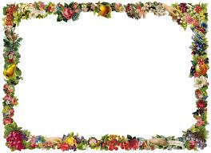

**1. This exciting exhibition is centred on cutting-edge developments in the field of ecological architecture and technology.**

**What does field mean?**

**a. grassland b. area of interest**

**2. The city space station will be built on top of existing high rise buildings and will make use of solar power.**

**What does power mean?**

**a. energy b. authority**

**Rewrite the sentences using conditional sentences.**

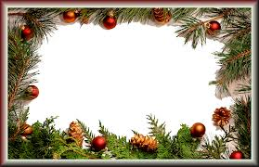

|  |
| --- |
| **1. I can’t help you because I have a lot of work.**  **If I didn’t----------------------------------------------------------------------------------------------------------------------------------------------------.**  **2. You must study hard, otherwise you won’t get into the university you want.**  **If you --------------------------------------------------------------------------------------------------------------------------------------------------------.**  **3. The ferry stops running in very poor weather conditions.**  **If weather conditions -------------------------------------------------------------------------------------------------------------------------------------.** |









**Name:**

**.....................**

**Unit: 6**

**Lesson: 3**

**Classroom:**

**.....................**

**Activity:**

**....................**

**English working paper**



***B. Match the phrasal verbs in bold with their meanings.***

**stick to - continue - stay away from - not reveal - keep under control**

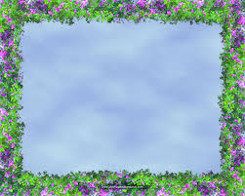

1- Hey you, **keep off** the grass! (**---------------------------**)

2- Despite the heavy rain, the boys **kept on** playing football. (**---------------------------**)

3- **Keep to** the speed limit or else I’ll get out of the car. (**---------------------------**)

4- It’s getting too loud in here, **keep** it **down**!

(**---------------------------**)

5- Why do you always **keep back** all the interesting gossip? (**---------------------------**)

***Read the sentences and circle the correct answer.***

**1. I think we can’t / might find olive oil in this shop, let’s try.**

**2. John isn’t answering the phone; he can’t / may be in the bathroom.**

**3. Henry must / might be here; I’m sure I heard his voice.**

**4. That can’t / won't be Julia; she’s in London at the moment.**









**Name:**

**.....................**

**Unit: 6**

**Lesson: 4**

**Classroom:**

**.....................**

**Activity:**

**....................**

**English working paper**



***What are some things we can do to save energy?***



___________________________________________________________________________________________________________________________________________________________________________________________________________________________________________________________________________________________________________________________________________________________________________________________________



**_____________________________________________________________________________________________________________________________________________________________________________________________________________________________________________________________________________________________________________________________________________________________________________________________________________________________**

**Do you do any of them? Why? Why not?**









**Name:**

**.....................**

**Unit: 6**

**Lesson: 5**

**Classroom:**

**.....................**

**Activity:**

**....................**

**English working paper**



***Solar power is an alternative form of energy that is environmentally friendly and inexpensive. Write your essay (150-175words).***

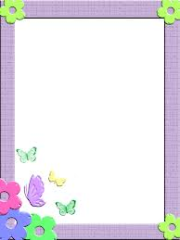

**________________________________________________________________________________________________________________________________________________________________________________________________________________________________________________________________________________________________________________________________________________________________________________________________________________________________________________________________________________________________________________________________________________________________________________________________________________________________________________________________________________________________________________________________________________________________________________________________________________________________________________________________________________________________________________________________________________________________________________________________________________________________________________________________________________________________________________________________________________________________________________________________________________________________________________________________________**









**Name:**

**.....................**

**Unit: 7**

**Lesson: 1**

**Classroom:**

**.....................**

**Activity:**

**....................**

**English working paper**



1. ***Do you like visiting museums? Why / Why not?***

**_______________________________________________________________________________________________________________________________________________________________________________________________________________________________________________________________________________________________________________________________________________________________________________________________________________________________________________________________________________________________________________________________________________________________________________________**

1. ***What kind of exhibits can you see in the following types of museums?***

**_____________________________________________________________________________________________________________________________________________________________________________________________________________________________________________________________________________________________________________________________________________________________________________________________________________________________________________________________________________________________________________________________________________________________________**









**Name:**

**.....................**

**Unit: 7**

**Lesson: 2**

**Classroom:**

**.....................**

**Activity:**

**....................**

**English working paper**



***Complete the sentences using the correct form of the words in the box.***

**rise - raise - arise - lift**

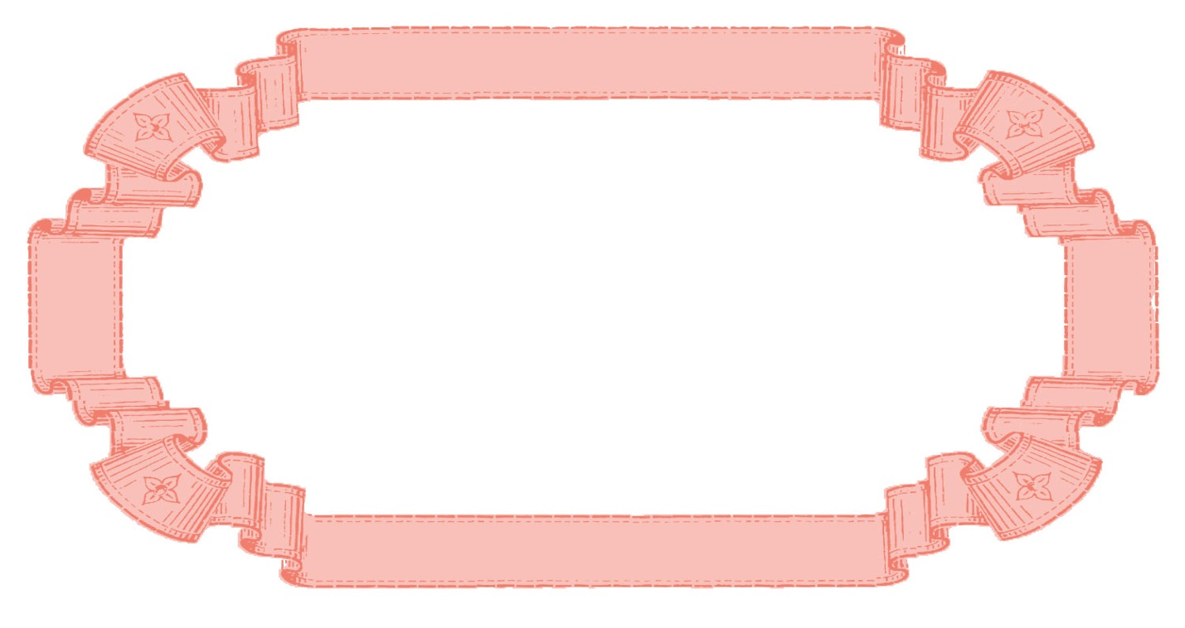

1. **No one understands how hard it is to --------------children until they have done it themselves.**
2. **Ever since the price of petrol has ---------------, many people cannot afford to drive their cars.**
3. **Can you help me --------------- these boxes? They are really heavy.**
4. **You shouldn’t get disappointed when a problem ------------------.**

***Write the adjectives which derive from the verbs/nouns given.***

**fame**

**history**

**hour**

**impress**

**access**

**nature**

**-------------------------------**

**-------------------------------**

**-------------------------------**

**-------------------------------**

**-------------------------------**

**-------------------------------**









**Name:**

**.....................**

**Unit: 7**

**Lesson: 3**

**Classroom:**

**.....................**

**Activity:**

**....................**

**English working paper**



Use the words in the boxes to complete the sentences.

|  |
| --- |
| ***earn – invest - gain - wi.*** |

|  |
| --- |
| 1. **He has worked hard all his life and ----------------- enough money to enjoy his retirement.** 2. **David is sure that he will ----------- the short story competition.** 3. **There is really nothing to ------------- by being so mean to people.** 4. **You should ------------------ your money in the stock market.** |

***Complete the sentences using the present or past participle of the verbs in brackets.***

1. **All the letters ----------------- (write) by the new secretary need rewriting.**
2. **All the artists ------------------ (take) part in this exhibition are from Saudi Arabia.**
3. **There were lots of people in the manager’s office -------------------- (complain) about the poor service.**
4. **You will also get a cap and backpack ------------------ (include) in the price of the holiday.**









**Name:**

**.....................**

**Unit: 7**

**Lesson: 4**

**Classroom:**

**.....................**

**Activity:**

**....................**

**English working paper**



***Discuss the following questions. You can use some of the words and expressions in the box.***

**broaden one’s mind stimulation - understand one’s culture - appreciation of the arts - acquire knowledge - creative pastime**

1. ***Why do you believe visiting art galleries and museums is important?***

**____________________________________________________________________________________________________________________________________________________________________________________________________________________________________________________________**

1. ***What is the most impressive work of art you have ever seen?***

**____________________________________________________________________________________________________________________________________________________________________________________________________________________________________________________________**

1. ***If you were an artist, what would you like to create? Why?***

**____________________________________________________________________________________________________________________________________________________________________________________________________________________________________________________________**









**Name:**

**.....................**

**Unit: 7**

**Lesson: 5**

**Classroom:**

**.....................**

**Activity:**

**....................**

**English working paper**



**Use the notes below to write sentences you could use in your response to your friend's letter.**



**1. Express enthusiasm about visit ------------------------------------------------------------------------------------------------------------------------------------------------------------------------------------------------------------------------------------------------------------------------**

**2. No interesting art exhibitions in June, suggest doing something else ----------------------------------------------------------------------------------------------------------------------------------------------------------------------------------------------------------------------------------**

**3. Give information about alternative activities ----------------------------------------------------------------------------------------------------------------------------------------------------------------------------------------------------------------------------------------------------------------**

**4. Ask your friend to respond as soon as possible --------------------------------------------------------------------------------------------------------------------------------------------------------------------------------------------------------------------------------------------------------**









**Name:**

**.....................**

**Unit: 8**

**Lesson: 1**

**Classroom:**

**.....................**

**Activity:**

**....................**

**English working paper**



***Do you think that compiling a dictionary is a demanding task? Why/Why not?***

___________________________________________________________________________________________________________________________________________________________________________________________________________________________________________________________________________________________________________________________

Match the words with their meanings.



|  |  |
| --- | --- |
| 1. **acquiring** 2. **compilation** 3. **cornerstone** 4. **concise** 5. **comprehensive** 6. **advancement** | 1. **brief** 2. **getting** 3. **most important part** 4. **improvement** 5. **collecting and putting together** 6. **complete** |









**Name:**

**.....................**

**Unit: 8**

**Lesson: 2**

**Classroom:**

**.....................**

**Activity:**

**....................**

**English working paper**



Complete the sentences using the correct form of the words in the box.

**consist - involve - contain - include**

1. **Does the hotel --------------------- a vegetarian menu in its restaurant?**
2. **How many countries does the European Union ----------of?**
3. **Those books ------------------- useful information on gardening.**
4. **Before I accept the job, I would like to know if it -------------------------------- a lot of travelling.**

***Complete with [in and out of] or both of them to form prepositional phrases.***

**1. -------------------- advance 2. --------------------brief**

**3. --------------------charge 4. --------------------time**

**5. --------------------order 6. --------------------breath**

**7. --------------------date 8. --------------------a hurry**









**Name:**

**.....................**

**Unit: 8**

**Lesson: 3**

**Classroom:**

**.....................**

**Activity:**

**....................**

**English working paper**



***Use the words in the box to form nouns describing occupations and put them in the correct column in the table.***

**mathematics - direct - report - produce - instruct - plumb - politics - science - art - type - electricity - operate**

|  |  |  |  |
| --- | --- | --- | --- |
| **-er** | **-or** | **-ist** | **-ian** |
|  |  |  |  |
|  |  |  |  |
|  |  |  |  |

***Read the sentences and complete the blanks with the appropriate modal verb + have and the past participle of the verbs in brackets.***

1. **My mum ------------------------------------- (tidy) my room while I was out. No one else would have done it.**
2. **The man you saw at the supermarket ------------------------------------- (be) Jack. He’s been living in Peru for two years now.**
3. **I’m sorry but all our tables are occupied. You --------------------------------- (call) to reserve a table yesterday.**
4. **You ------------------------------------- (hear) of him. He has written a collection of short stories for children.**









**Name:**

**.....................**

**Unit: 8**

**Lesson: 4**

**Classroom:**

**.....................**

**Activity:**

**....................**

**English working paper**



***Discuss the following questions. You can use some of the words and expressions in the box.***

**convenient - books in easy reach for students - enjoyable - informative/educational - a part of our culture – entertainment - pass the time - expand knowledge - learn about past/present**

1. **In your opinion, what are the features that make a book important?**

**____________________________________________________________________________________________________________________________________________________________________________________________________________________________________________________________**

1. **Is it important for schools to have a library with a variety of books?**

**____________________________________________________________________________________________________________________________________________________________________________________________________________________________________________________________**

**______________________________________________________________________________________________________________________________**

1. **Why do you believe people read books?**

**____________________________________________________________________________________________________________________________________________________________________________________________________________________________________________________________**









**Name:**

**.....................**

**Unit: 8**

**Lesson: 5**

**Classroom:**

**.....................**

**Activity:**

**....................**

**English working paper**



***Write a review (120 - 180 words) to describe your favourite book and say what you like about it.***

**____________________________________________________________________________________________________________________________________________________________________________________________________________________________________________________**

**____________________________________________________________________________________________________________________________________________________________________________________________________________________________________________________**

**____________________________________________________________________________________________________________________________________________________________________________________________________________________________________________________**

**____________________________________________________________________________________________________________________________________________________________________________________________________________________________________________________**

**____________________________________________________________________________________________________________________________________________________________________________________________________________________________________________________**

**____________________________________________________________________________________________________________________________________________________________________________________________________________________________________________________**

**____________________________________________________________________________________________________________________________________________________________________________________________________________________________________________________**