**Revision Unit 3 .. Crossing cultures** 2nd grade secondary

**1- Write an essay about ( Bint Al Shatia ) , using the given information and write a suitable title :**

( Aisha Abdulrahman – Islamic scholar , journalist and professor – born in Egypt – start studying at age of 5 – studied bachelor , master and doctorate - worked as a teacher in Cairo , Sudan , Morocco, Lebanon ,and Saudi Arabia – wrote books – died in 1998- respected as Islamic scholar )

--------------------------------------------------------------------------------------------------------------------------------------------------------------------------------------------------------------------------------------------------------------------------------------------------------------------------------------------------------------------------------------------------------------------------------------------------------------------------------------------------------------------------------------------------------------------------------------------------------------------------------------------------------------------------------------------------------------------------------------------------------------------------------------------------------------------------------------------------------------------------------------------------------------------------------------------------------------------------------------------------------------------------------------------------------------------------------------------------------------------------------------------------------------------------------------------------------------

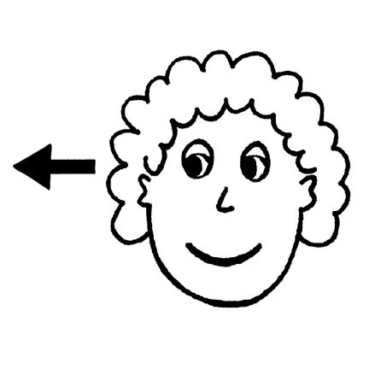2-

**Third Conditional** : If + past perfect + would + perfect infinitive

If I had left earlier, I would have caught the plane

**Correct the verb between brackets :**

a- If mark had -------------------- **( tell )** me about the meeting , I would have gone

b- If I ----------------- **( have )** studied , I wouldn’t have failed

c- If it hadn’t rained last night , we have -------------------------- **( eat )** outside

d- I would have visited you if I had ------------------------ **( come )** to Jeddah .

3-

**Expressing wishes** : wish + past perfect

I wish you had given her the sweets

**Rewrite the sentences using ( wish+ past perfect ):**

a- My brother lost his job

---------------------------------------------------------------------------------------

b- I didn’t have a breakfast

-----------------------------------------------------------------------------------------

4-

**Present simple** :

( She , he , it ) v+s ( does )

Samar goes to school everyday

( they – we – you – I ) v + $ ( do )

They play football everyday

**Choose the correct answers :**

a- Muslims **( Pray – prays )** everyday

b- Samar **( draw – draws )** pictures every weekend

c- Ali **( study – studies)** history in the university.

**5- Complete the table about weddings ceremonies in Saudi Arabia:**



It takes place in ---------------------------------------------------------------------------

Who attends the ceremony ---------------------------------------------------------------

What they where -------------------------------------------------------------------------What they eat -----------------------------------------------------------------------------

What happens during the ceremony ------------------------------------------------------

----------------------------------------------------------------------------------------------

**6- Give on Example :**

University Subject :---------------------------------

Women’s job: ----------------------------------------

Men’s job: -------------------------------------------

**7- Samar is moving to a new school tomorrow , Give her 2 advices :**

----------------------------------------------------------------------------------------------------------------------------------------------------------------------------------------------------------------------------------------------------------------------------------------------------------------------------------------------------------------------------------------------------------------------------------------

Prepared by

Teacher ..Bushra Assiri