**Revision Unit 5** : Stages of Life 2nd Grade Secondary

**1- Match the words with their meanings :**

a- a baby - father and mother

b- a teenager - a very young child

c- a toddler - aged between 13 and 19 years old

d-parents - a child who is starting to walk or a child between 2 and 3 years.

**2- Fill in the spaces in the table , by using Piaget’s theory about cognitive development of children :**

|  |  |
| --- | --- |
| ‘Sensorimotor stage’ | From ---------------- to age -------------------- |
| ‘ preoperational ‘ stage | From age----------- to age ---------------------- |
| ‘ concert operational stage ‘ | From age --------------- to age -------------- |
| ‘ formal operational stage ‘ | From age ------------------ |

3-

**Future simple**  **future continuous**

* Complete activity * open ended activity

**Will** + **infinitive** **will** + **be** + **(v+ing)**

I **will** **go** to university next year I **will** **be** **waiting** for you.

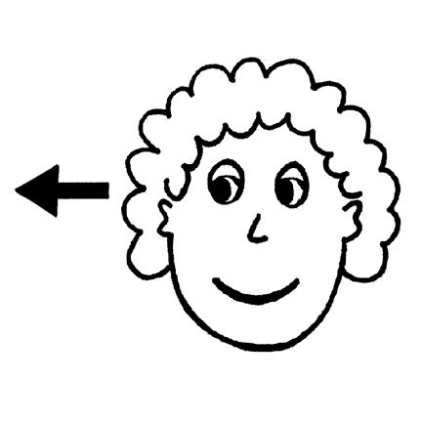

**Correct the verbs between brackets :**

a- I ------------------------------- **( wait )** for you , don’t be late .

b- I ------------------------------- **( travel )** to Makah next Saturday .

c- in ten years , we ----------------------------- **( live )** in bigger house , I hope.

4-

**Connectives :**

Because – so – only if – therefore – if – unless

**( However – but – although)** contrast the two parts of the sentence



**Choose the corret connectives :**

a- He didn’t have much money-------- **( but – unless )** he wanted to travel

b- He is sick . -------- , **( Therefore – However )**he will not go to school

c- --------- **( If – So )** he study hard , he will success .

d- I am not going to leave my country ------- **( unless – so )** there is an emergency .

5-

**Questions and question words :**

**The question words** : **[ How – What – When – Where – Who – Which ]**

When we ask about the subject , nothing change .. just delete the question word .. Don’t add auxiliary or helping verb like do does or did.

**Faisal** played tennis  Who played tennis ?

**Ask a question about the underlined words :**

a- **My father** told me to apply for the scholarship .

---------------------------------------------------------------------------------------

b- I want to study **Arabic .**

---------------------------------------------------------------------------------------

c- I got **20000** as a salary every month

----------------------------------------------------------------------------------------

d- **A university** offered me a scholarship .

----------------------------------------------------------------------------------------

**6- Comprehension : Answer the questions from the text below :**



a- How old is the grandmother ? -------------------------------------------------------

b- Two adjectives to describe how the grandmother look ----------------------- and ------------------------

c- Two positive adjectives of her ------------------------------- and-------------------------------------------

d- Two negative adjectives -------------------------------- and -------------------------------------------------

e- Two connectives showing contrast ------------------------------------ + ------------------------------------

f- Was she living in Jeddah in the past ? ----------------------------------------------------------------------

g- Describe the author’s feelings towards her in short words ? -------------------------------------------------------------------------------------------------------------------------------------------------------------------

**7- Write a sentence about these people’s goals in life :**

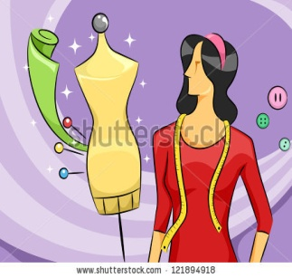

a- b- c- a------------------------------------------

-------------------------------------------

b------------------------------------------

-------------------------------------------

c------------------------------------------

-------------------------------------------------------

prepared by

Teacher .. Bushra Assiri