**The Kingdom of Saudi Arabia**

**Ministry Of Education.**

**Name:……………. Class:……………**

**الصف الثاني المتوسط**

**English Written Mid Term Exam 1433-1434 H- 2nd Term -**

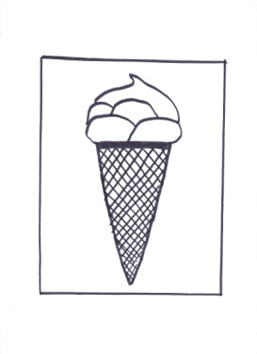

**10**

***Q1. Select the correct letters :***

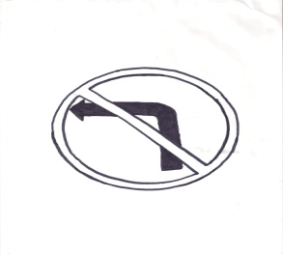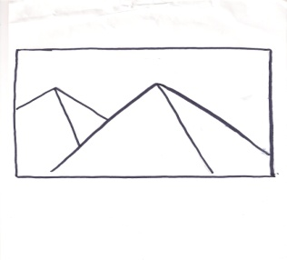

1. Pyr—mids . 2. Don't t—rn left. 3. –-ce-ream

( a - e - o- u- i)

( a - e - o- u- i)

( a - e - o- u- i)

Q2:Answer the questions:

a. What time is it ?

{ 300 m long – 12 o'clock – 300 m high .}

b. Where were you yesterday ? I was …………………………..

{go to the mechanic - see a doctor . - sick . }

Q3: Choose ;

1.He is writing is ( clear– clearly ) .

2. My report is { good- better – best.

3. Riyadh is as ( crowded – more crowded – most crowded ) as Jeddah .

4. ( Was- Were ) Ahmad and his brother in Makkah last week ?

5. Ali is ( in – over – on ) the mosque.