Revision

Unit 3

I- Dialogue

**Rearrange the following dialogue between Danah and Fatima :**

**Danah :** what were you doing on Saturday night ?

**Fatimah:**  reading / . / a / was / I / book ………………………………………………………………………………

Danah : like / you / Do / reading / ? …………………………………………………………………………………….

Fatimah : do / , / Yes / I ……………………………………………………………………………………………………….

______________________________________________________________________________________________________

II- comprehension :

**A-Read the text and answer the questions below :**

Reem has a lot of hobbies and interests. She usually gets up early so she can run before work. Reem often rides a horse at a stable near her home. she usually goes horseback riding on Sundays. She never watches TV because she likes doing things outside home . She usually goes to the gym if it's raining outside. She isn't often alone because she has a lot of friends. She occasionally does something alone, but she usually does her activities with one of her friends. She's a happy woman!

1-**Answer the following questions :**

**a-**  Does Reem usually run ? …………………………………………………………………………………………………………………….

b- When does Reem go horseback riding ? ………………………………………………………………………………………………

**2-Choose the correct answer :**

|  |  |
| --- | --- |
| **b- She never watches TV because….**  1-She likes to sleep .  2-She likes doing things inside home.  3- she likes doing things outside home. | **a- Reem is a happy woman because ….**  1- she has a lot of friends .  2- she's always alone .  3- She's rich |

III- Grammar

**A-Choose the correct answer** :

1-They ( was – am –were ) studying last night .

2- What ( were – was – is – are ) you doing last Sunday ?

3- I ( was – were –am – is ) reading a book at this time last week .

4- She ( was – were –is – are ) sleeping all day yesterday .

5- I was ( watch –watching – watched ) TV from 6 o'clock till 9 .

6- I was running when I ( fell –fall –falling ) in the hole .

7- While I ( was watching – watched –watch )TV , I slept.

8- She used to ( read – reads – reading ) a book every week .

**B – do as shown between brackets :**

1-While they (play ) football , It ( rain) . ( correct the verb )

…………………………………………………………………………………………………………………………..

2- I used to sleep early . ( change into negative ( not )

………………………………………………………………………………………………………………………………………….

3-- She was sleeping all day yesterday . (make yes / no question )

………………………………………………………………………………………………………………………………………………

**IV-Vocabulary :**

**A-Match the word with its meaning :**

|  |  |
| --- | --- |
| Not dangerous  A long way from the top to bottom  Stupid  Asking someone about her /his problem  clever | 1-What's wrong ?  2- silly  3-deep  4-safe |

**B-Choose the correct word :**

|  |
| --- |
| 1- give up 2- fall in 3-turn on 4- ride |

a-Please ! ……………….the light . It's very dark .

b-I ……………………………… ! I can't play this game .

c- Be careful ! Don't ………………………….. in the water.



**___________________________________________________________________________________________**

**V –orthography**

**A-Write what you hear :**

**1-**………………………………………………………………... 2-……………………………………………………………………..

3-……………………………………………………………….. 4-……………………………………………………………………

________________________________________________________________________________________________________.

**VI- Writing :**

**Write a paragraph about what happened to teacher Hani using while , when , and ,so .**



****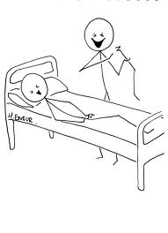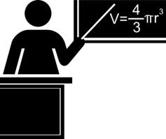

Take to

Break - leg

run

His friend

Now

Hani

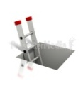

Fall in

