الاسم .................................................................. الصف .......................................

**1/ Listen and number 1 for a and 2 for a\_e.**.

**cap tape**

**2/ Match then Read and copy :**

Playing football - doing karate - eating snack

|  |  |  |
| --- | --- | --- |
| sparring-clipart-TKD_kick.png | 2649542-Boy-Eating-Junk-Food-Stock-Vector.jpg | C:\Users\PC\AppData\Local\Microsoft\Windows\Temporary Internet Files\Content.IE5\F7XLQTR2\cartoon-boy-playing-football-thumb8774883[1].jpg |

**3 / choose the correct word:**

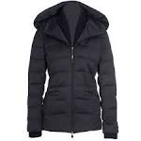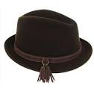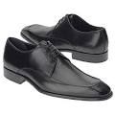 1-Sunglasses 2– hat 3– shoes 5- jacket

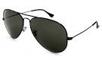

…………… ………………. ……………… …………….

**4/ Choose**

hot / hat cold / col

**5/ what the matter**

? / .

6/**Rearrange**

**whose book is this ?**

Mine / it / is