Name: .............................................................

Class: .........................

|  |  |
| --- | --- |
| ball.png | -books-clip-art.jpg |

*1- Choose the correct words:*

1. The books are on [ the right - the left - next to ].
2. 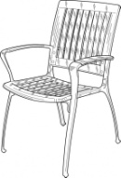 The ball's on [ the right - the left - next to ].
3. 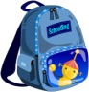The bag's [ the right - the left - next to ] the chair.
4. What is [ it - they - you ] like ?
5. I'm [ eat - eats - eating ] breakfast.
6. It's Monday the [ four - fourteen - fourth ] of March.
7. It' Friday the [ sixth - six - sixty ] of December.
8. [ Why - What - Can ] you read it , please ?

*2- Correct:*

a) I am ( have ) ........................... lunch.

b) He is ( read ) .................................. a book.

c) They are ( write ) ................................... homework.

d) She is ( watch ) ................................ TV.

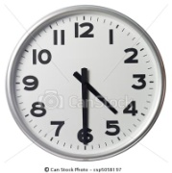

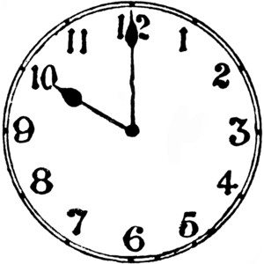 *3- What's the time ?*

a) ................................................................ a) b)

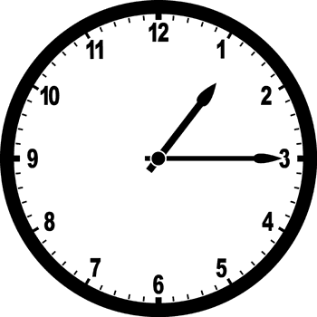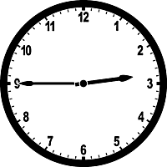 b) ................................................................

c) ................................................................

d) ................................................................. c) d)

*4- Write correctly:*

a) canigototheparkplease ....................................................................

b) caniwatchtvplease ...........................................................................

c) canwegohomeplease .......................................................................

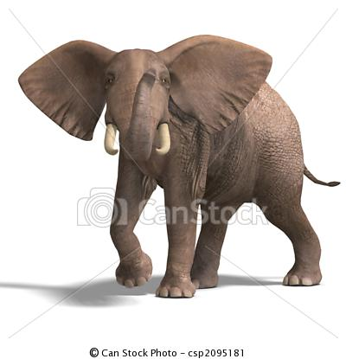B-day_Guest2.jpg

*5- Complete:*

a) What's it like? b) What's he like ?

....................................................... ......................................................

-1-

*Spring - Tuesday - library - January -*

*Winter - Monday - April - office*

*1- Complete the table with these words:*

|  |  |  |  |
| --- | --- | --- | --- |
| days | months | seasons | school |
|  |  |  |  |
|  |  |  |  |

*2- Circle the odd words:*

*bedroom*

*classroom*

*library*

*office*

*September*

*Spring*

*January*

*October*

*Friday*

*Saturday*

*Thursday*

*June*

*Summer*

*Autumn*

*Sunday*

*Winter*

a) b) c) d)

*3- complete the card:*

*...................... : Faisal Saleh*

*...................... : 12*

*Occupation: ......................................*

*Nationality: .......................................*

*student*

*Name*

*Saudi*

*Age*

4- Write the correct word under each picture:

*stairs - library - reading - cooking - writing - playing - eating - drinking*

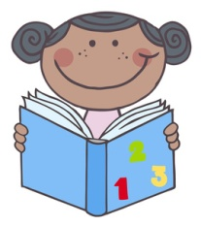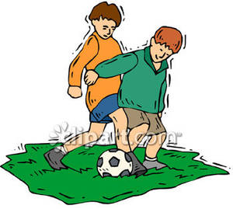

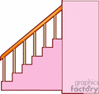

a) ............................... b) ................................. c) ................................ d) ................................

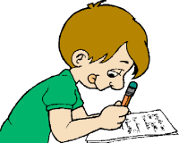

e) ................................ f) .................................. g) ................................. h) ..................................

.

*Write correctly:*

\_\_\_\_\_\_\_\_\_\_\_\_\_\_\_\_\_\_\_\_\_\_\_\_\_\_\_\_\_\_\_\_\_\_\_\_\_\_\_\_\_\_\_\_\_\_\_\_\_\_\_\_\_\_\_\_\_\_\_\_\_\_\_\_\_\_\_\_\_\_\_\_\_\_\_\_\_\_\_\_\_\_

\_\_\_\_\_\_\_\_\_\_\_\_\_\_\_\_\_\_\_\_\_\_\_\_\_\_\_\_\_\_\_\_\_\_\_\_\_\_\_\_\_\_\_\_\_\_\_\_\_\_\_\_\_\_\_\_\_\_\_\_\_\_\_\_\_\_\_\_\_\_\_\_\_\_\_\_\_\_\_\_\_\_

-2-