**Search title**

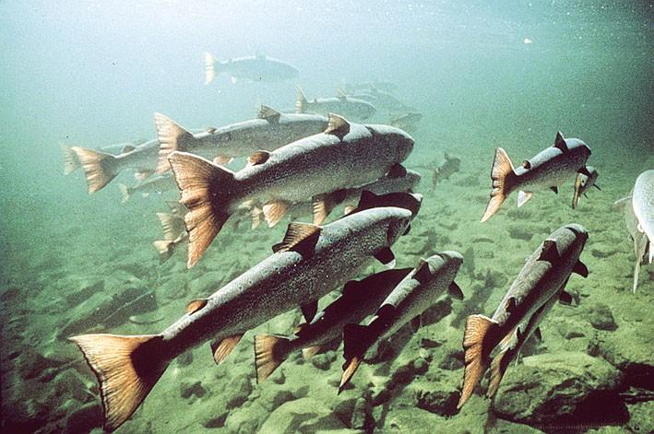**Fish migration**

**Introduction:**

Divide fish into three groups depending on their hulls; algrith fish walglki fish for his lies, skates and sharks either, Chondrichthyes, bony fish include finfish (salmon, tuna) radial, split fin.

Fish the untying cartilaginous fish bony fish.

Fish environment: fish is vital indicators of system health, when declining fish non-commercial groups, the main reason is climate change. When the decreasing numbers of fish not be negatively on human beings, but also ecosystems may suffer from unbalance.

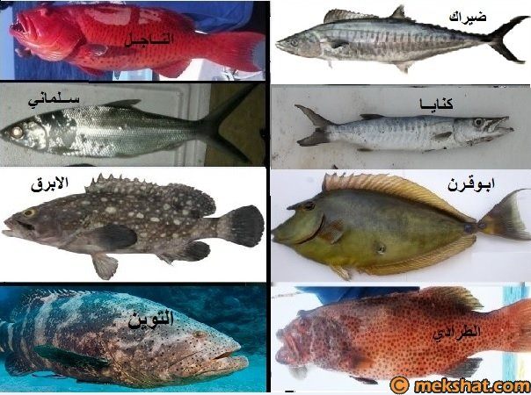

**Fish migration:**

Are fish migration agents keep her where immigration either for food or move to less water pollution or to lay eggs and reproduce as well as for the winter, but the data migration for reproduction is one of the puzzles that puzzled scientists since moving to distances of up to thousands of kilometers.

In the marine environment not dependent on fish movement the stars or the Sun where fish move in an environment that does not show any signs nor rely on the experience of parents especially in the case of collective death of parents after spawning as in the lacertine snake but put scientists some theories to explain this emigration from these theories.

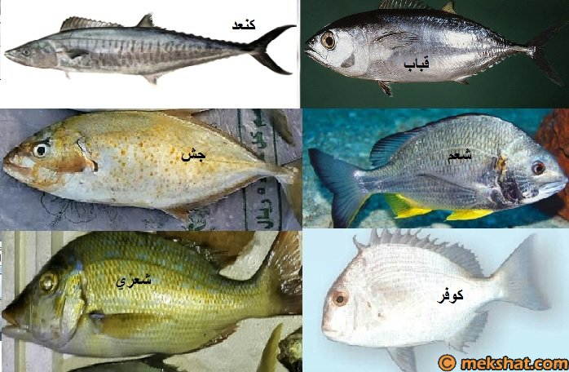

The theory of magnetic maps of the land: -

As we all know that the land of a magnetic field, and therefore Taatfouat severity of these magnetic fields from one area to another and so maps scientists draw to illustrate the intensity of magnetic fields on Earth, scientists believed that migratory fish rely graduate and scientists have been based on the movement of sharks ongoing South America to Australia in the semi-specific track back and promises to explain this theory.

Among the explanations of this theory is the process of suicide mass of whales where Ttrg whales in the form of groups, each group commander in the event of a malfunction in the device to determine the location of the group's leader group was heading into the shallow water and no internal pressure Allaudh Other times, which asserts it is that in case of rescue one whale speeding back to the bottom where he does not show any desire to commit suicide.

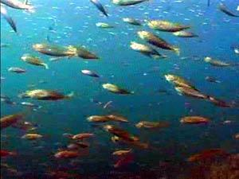

The theory of genetic memory : -

Explained by the presence of sharks and whales at a specific time when the fish found in large quantities during the journey , such as herring and salmon

Theory rely on ocean currents : -

Where the ocean currents move the fish to other areas

Causes of migration :

1. Migration to lay eggs

2. abandoned to search for food

3. Beat the winter migration.

**The factors that drive the fish to migrate : -**

The factors that drive the fish to migrate to biological factors and natural factors are divided .

Biological factors that drive the fish to migrate :

1. The development of the situation of sexual Fish

2. the amount of fat stored in the body

3. gravitate towards Aldae

4. genetic memory

5. Changes in blood pressure Fish.

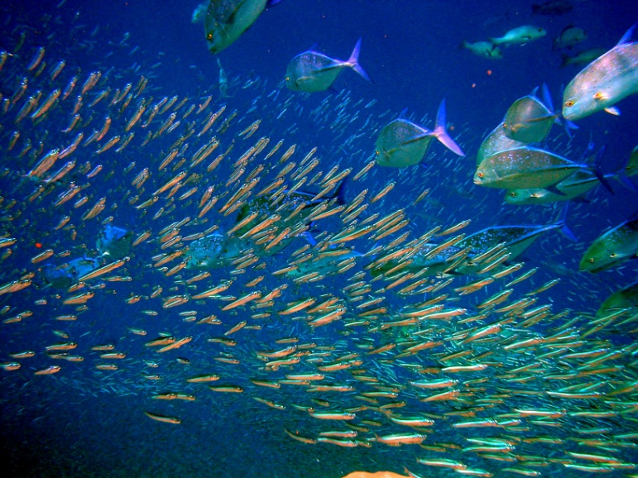

**Natural factors :**

1 - Heat

2 - pressure air and the atmospheric condition

3 - water currents

4 - natural properties of water

This and migrate from one means of increase is the kind where the fish that migrate longer distances available in nature are more than that migrate distances less immigration also helps to protect young fish are larger in places ovulation and provide them with food and fast growth.

**Fish migration - Part II:**

In this section we will explain the reasons for the migration of fish , as we know from the previous topic that the causes of migration

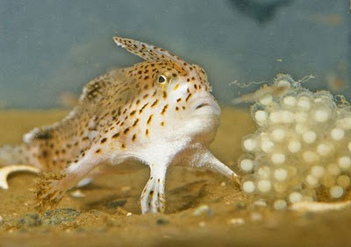1. Migration to lay eggs

2. abandoned to search for food

Immigration to lay eggs : -

Immigration is divided to lay eggs to :

1. migration from the sea

2. migrate to the sea

3. abandoned into the sea

4. abandoned inside the fresh water.

**1. migrate from the sea:**

And is the fish that live their life span in the sea and migrate to rivers for spawning, such as salmon

2. migrate to the sea

And is a fish that lives in rivers and lakes and migrate to the sea to lay eggs, such as mullet and eel

3. abandoned into the sea

And marine fish are not out of the sea, but moving distances may be longer or shorter to lay eggs, such as herring, sardines

4. abandoned inside the fresh water

And Fish is a movement within the water such as tilapia and carp and Alqurmat

This and most primitive types of immigration shortly before the egg-laying season, but some migration of Fulbright grants Bayat first winter then puts the eggs at the end of the winter, such as some types of salmon and Alastrzin.

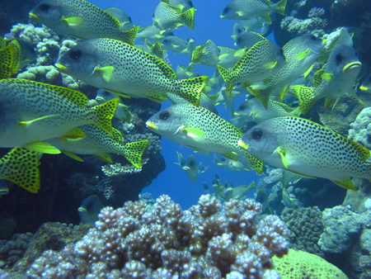

**Immigration to search for food: -**

It is not a random deserted and abandoned, but in the memory of deceased fish where the fish move at the same time of the year to the same place to the availability of food in a cafe for growth and reproduction

And divided abandoned food to migration has negative and positive migration

**1. Immigration negative: -**

And are Tbdaiha fish to Azlat in the process of egg before hatching where water currents carry the eggs of some fish species and pushed into areas infested with Alngveo this migration may be abandoned horizontal or vertical and may occur for some types of fish larvae after hatching

**2. migrate the positive: -**

And that moving fish from one area to another to the availability of food in the region and the broader types of immigration Faqih to search for food is abandoned herring and immigration may be vertically from the bottom to the surface, or vice versa depending on the light and heat.

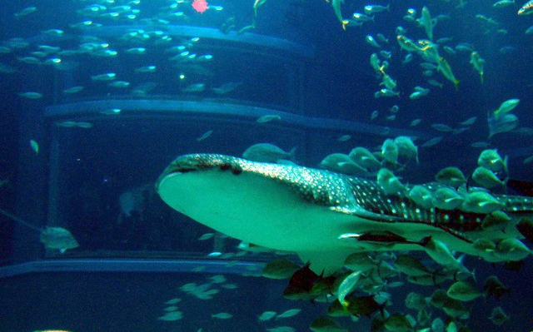

**Beat the winter migration of : -**

In this type of immigration Fish looking for warm water , therefore this type does not occur from the migration of some types of fish and seafood to the presence of the great depth in the seas and oceans , which help create a layer -water warm and suitable for the life of the fish .

But who is the is the most types of freshwater fish with less physical activity , and it goes on the winter period in the mud and Fulbright grants Bayat winter storage after the appropriate amount of fat in their bodies

This and that we note that the same species of fish may find some individuals exercising their activity in nature and others may epidemic in Bayat winter .

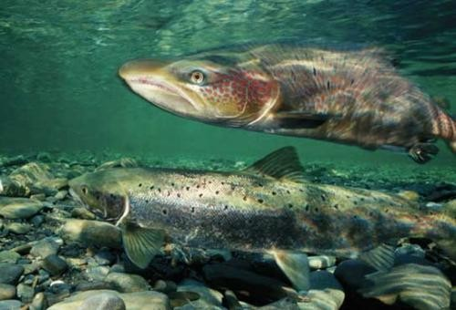

Conclusion

Most fish belong to non-migratory animals usually live in the zone, especially during the period of growth. Also find our jealous types of fish (Pilgrim), which lasts between periods of great migrations require a tremendous amount of energy. These migrations from certain hormonal processes associated with sexual development: a number of physiological asymmetries that pay to fish movement and migration for rebalancing. highlights in particular two types of migrating fish that spend most of their life in travel:

Salmon and eels.

Live eels in fresh water but comes out to sea to lays eggs. Either salmon, trip. This requires lay eggs, for many fish, a great deal of effort, stop

Fish eating (for hope or partial) throughout the breeding and become very seriously underweight and flagging

At the end of the process.