**Revision Unit 6.. The Future** **2nd grade secondary**

**1- write the name of the category :**

a-[ --------------------------- ] : vaccine against a polio , cure for cancer

b-[ --------------------------- ] : weather control , protection of endangered species

2-

**Future perfect:** action which will be completed in a specific time in the future

**In ( time ) , (will- might- should) + have + 3rd (v)**

In 2030, we will have travelled to space

**Might** possibility , **should** probability , **will** certainly

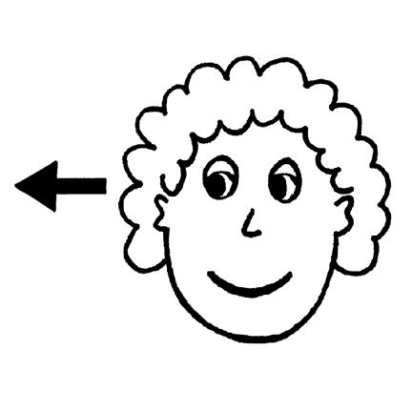

**Correct the verb between brackets :**

a- In 2016, we ------------------------------------------ **( return to)** my country , Saudi Arabia.

b- In 2050 , people ------------------------------------ **( invent )** time travel.

c- By the time I’m 60, ---------------------------------- **( have )** a lot of interesting experiences .

**3- Match the words with their meanings :**

a- To create - speed

b- rapidity - to make

c- to protect - to keep away from

d- to avoid - to take care of

**4- Choose the correct words under the pictures :**

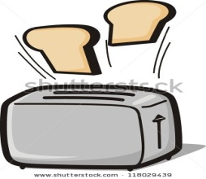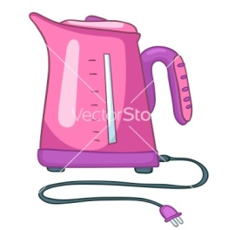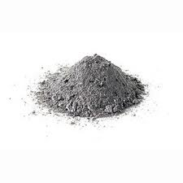

a-( ashes-cuisine ) b-( kettle- rice maker ) c-(toaster – bread maker )

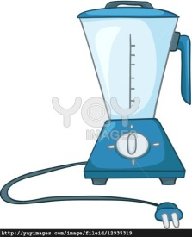

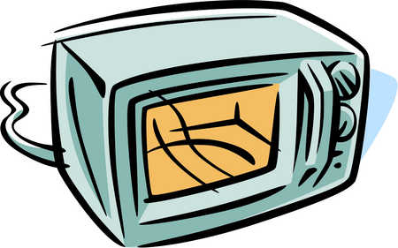

d-(juicer – blender ) e-(microwave- pot)

**5-**

**Clauses of Purpose** :

**so that**  I prepared lunch **so that I could** get to my lesson on time

**To** I use the kettle **to boil** water

**Do as shown between brackets :**

a- I took out a knife . I wanted to chop some onions. **[ use (to ) with the clause of purpose]**

----------------------------------------------------------------------------------------------------

b- I watched food programs. I wanted to get some inspiration for some new meals .

**[ use ( so that ) with the clause of purpose]**

---------------------------------------------------------------------------------------------------

**6- choose the correct answers :**

a- I go to the shopping mall to **( buy – buying )** a new dress.

b- I travelled to Makkah so that I **( could- can )** perform Omrah .

c- In 2010, we **( will move – will have moved )** to our new house.

**7- Comprehension :**



a- Where is the following text taken from ?

------------------------------------------------------------------------------------------------------

b- What should you do with your blender after using it ?

-------------------------------------------------------------------------------------------------------

c- How should you process meat ?

------------------------------------------------------------------------------------------------------

d- List two things you should not do with your blender ?

------------------------------------------------------------------------------------------------------

e- Why you should not reach into the blender with your fingers ?

------------------------------------------------------------------------------------------------------

f- give two things you would use a blender for ?

-------------------------------------------------------------------------------------------------------

g- underline **3** instructions in the text written by using the imperative form ..

**8-Dialogue : Asmaa and lama are talking about the Space Odyssey ..**

**Asmaa** : What is the Space odyssey ?

**Lama** : ------------------------------- for the director --------------------------------------------

**Asmaa** : Ah.. I remembered it .. it is about a computer called -----------------------------

**Lama** : yes , you are right . the computer had the ability to -----------------, ------------------,

----------------- and -----------------------------------

**Asmma** : It had a very ------------------------------ ending when they disconnected the computer

and it --------------------------------------

**9- Choose the correct answers :**

a- The 19th century was the era of : **[ industrialization – communication ]**

b- **[ Alternative energy sources – medicine ]** like : wind and solar power .

**10- Composition : Write your own plan for continuing to develop your English : [5 sentences only]**

------------------------------------------------------------------------------------------------------------------------------------------------------------------------------------------------------------------------------------------------------------------------------------------------------------------------------------------------------------------------------------------------------------------------------------------------------------------------------------------------------------------------------------------------------------------------------------------------------------------------------------------------------------------------------------------------------------------------------------------------------------------------------------------------------------------------------------------------------------------------------------------------------------------------------------------------------------------------------------------------------------------------------------------------------------------------------------------------------------------------------------------------------------------------------------------------------------------------------------------------------------------------------------------------------------------------------------------------

Prepared by

Teacher ..Bushra Assiri