**Module 2**

What an experience

1 - Complete the dialogue with phrases:

A ) I am afraid so - b ) How are things ? - c ) Can you give me a hand ? - d ) In other words , you don't want to help . - e ) You can follow the match and help at the same time . f ) o.k. thanks.

Mikle : Hello, Gavin . Can I ask you something ?

Jone : Sure .

Mikle : I'm moving house tomorrow afternoon .

…………………………………………………………..

Jone : Sorry , but there's a football match I really want to see.

Mikle : And it's in the afternoon, right ?

Jone : ……………………………………………………………………………….

Mike : Why don't you listen to it on the radio ?

………………………………………………………………………………………

Jone : Sorry I'm really looking forward to this match .

…………………………………………………………………………………………………………….

Mike : Don't be like that . I can come after the match and help tidy up.

Jone : ………………………………………..

2 – Choose the correct adjective :

1 – we left early because the lecture was { bored – boring }

2 – Nasir was { surprising – surprised } to see an old school friend on the train .

3 – Everyone was { excited – exciting } about the graduation .

3 - Match the phrases with their meaning :

1 – Merchant moving something upwards.

2 – handed Whole.

3 – raising gave.

4 – entire a person that sells things

4 – Choose the correct meaning :

1 – extreme { usual - great – danger }

2 – drop { go up - go down – high }

3 – survive { die - stay alive – serious }

4 – store { keep for the future - drink slowly – use regularly }

**A – Finally**

**B – then**

**C – bitter**

**D – lightning**

*5-* **Fill in the spaces with the correct answer :**

1 - I can't drink this coffee . it's too……………………..

2- When I saw the …………………… , I knew a storm was on its way .

3 – Bushra …………………….found her book under the sofa .

6 - Put the correct word under picture :

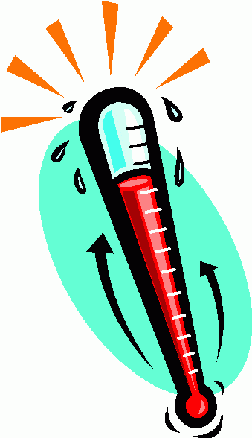Low temperatures - high temperatures - storms – lightning – thunder .

[](http://ponysquare.com/photo/17892/alberich/)[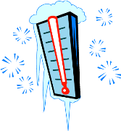](http://eloquentscience.com/wp-content/uploads/2012/05/cold+thermometer.png)[](javascript:edit(214292))

……………………………

……………………………

……………………………

……………………………

Grammar

1 - Do as shown between brackets :

1 –She has finished yet . {{ correct Mistake }}

……………………………………………………………………………………………….

2 – He was sleeping when the alarm went off. {{ Underline : T.c - M.c }}

………………………………………………………………………………………………..

3 - ……………………………………………this hose ? {{ Complete : Q }}

I have had it for two years .

2 - Choose the correct answer :

1 – I haven't played tennis ( for - since - just ) six years.

2 – Mohammed hasn't returned from work ( already - yet - before )

3 - We haven't spoken to each other ( since - been - for ) the summer .

4 - I have ( see – seen – saw ) him several times before .

3 - Complete the table with correct form of these verbs :

|  |  |  |
| --- | --- | --- |
| p.p , V3 | Past simple | Base form |
|  |  | fly |
|  |  | see |
|  |  | Leave |
|  |  | Eat |
|  |  | go |
|  |  | Write |
|  |  | Know |

Writing

*Read the e-mail below then look at the table complete it with phrases :

Hello Abdul- Rahman ,

How are thing ? Sorry I haven't written for so long , but I've been very busy with university . However , guess What ! I have some great news .

I am coming to Thuwal for my Master's . The king Abdullah University of Science and Technology accepted me ! I am looking forward to it , but I haven’t organized things yet and I'm a bit stressed . Luckily , some friends in Saudi Arabia are helping me arrange my accommodation . Anyway , I don't know exactly when I'm coming .but I'm looking forward to seeing you again after all these years.

So , what about you ? What have you been up to ? Do you still study hard like you used to ?

Well, that's all for now. Write back soon !

Yours,

Fred .

|  |  |  |  |
| --- | --- | --- | --- |
| Signature | Closing paragraph | Opening paragraph | Greeting |
|  |  |  |  |