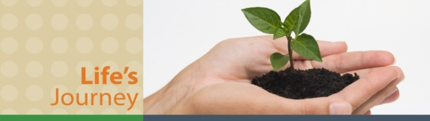**Revision Unit 4 ..**  2nd grade secondary

**1- Reorder the given words to confirm information and ask for things :**

a- help – can – you – I ?

--------------------------------------------------------------------------------

b- i– address – take – your email – may ?

--------------------------------------------------------------------------------

**2-Dialogue : Talal and his family want to go Abha for a vacation :**

**Talal** : We will travel to Abha , do you know any good hotels there ?

**Sami** : yes , --------------------------------------- hotel

**Talal** : Can you describe it for me ?

**Sami** : ------------------------, ------------------------- and--------------------------

**Talal** : What kinds of sports can we perform there ?

**Sami** : --------------------------- , ----------------------------- and --------------------------

**Talal** : It seems a good hotel to spend our vacation there , thanks for your help

**Sami** : ------------------------------------

**3- Choose the correct word under the pictures :**

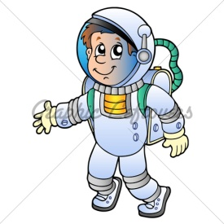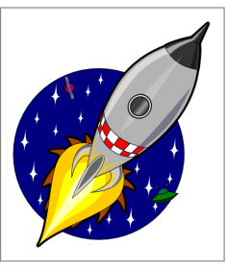

a-( space craft – ship ) b- ( aliens – astronaut ) c-( terrified – amused )

4-

**Past modals** : could have – might have- may have – must have - can’t have – should have

( Could , may , might) + have + 3rd ( v ) possibility in the past

Some people **might** **have** **panicked**

( couldn’t have + 3rd (v))  negative possibility in the past

I **couldn’t** **have** **imagined** this drama.

( must ) have + 3rd ( v )  definite , positive deduction

They **must** **have** **died**

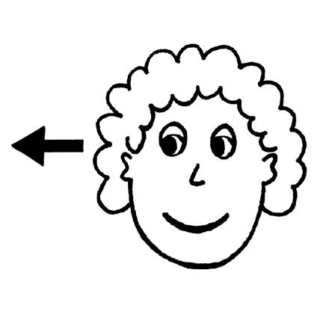

**Choose the correct answers :**

a- Jamie is never late . He **( can – must )** have had an accident.

b- It **( must – could )** have been engine failure. I am sure it was

c- They all **( must – might )** have **( be – been )** killed

d- Oh , no ! we are out of petrol . I should **( have fill – have filled)** before we left .

**5- Complete the given information:**

a- Farouq Al-Baz is -----------------------------------------

b- Neil Armstrong -------------------------------------------------------------------------

c- The war of the worlds is a name of a --------------------- in 1938

d- Sindibad the sailor is a kind of ----------------------- in the Arabic literature , he is from

----------------------------

**6- Write a suitable title for the given paragraphs :**

**a- the title : ------------------------**

Every body wishes having true friends . when we think about the friendship some of us say it means doing thins together . But it is deeply much more than that . Friendship is caring and sharing .Sharing feelings and dreams. That comes with time . True friends should depend upon each other and they have to be honest , too .But they have to be careful not to hurt each other 's feeling .A friendship should bring us joy not misery . Any body has true friends , he is really lucky.

**b- the title : ----------------------------**

Everyday, people produce tons & tons of garbage. Throwing away things is a wasteful habit. Recycling turns garbage into new things. They are four steps of recycling :First, collect material paper, glass.. etc. Second, put each material in a different group. Third ,send these materials to recycling unit. Fourth, change them into new things. Recycling has many benefits .It helps:

Prepared by

Teacher..Bushra Assiri