**Revision Unit 1..Trends** 2nd grade secondary

**1- Describe the pictures by using two adjectives :**

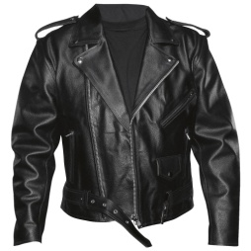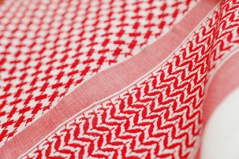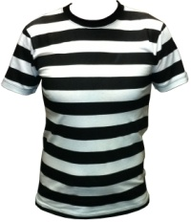1- 2- 3- 4-

1-------------------------------------------- 2-------------------------------------------

3-------------------------------------------- 4-------------------------------------------

**2- reorder the words :**

a- shoes , pair , tennis , a , white , of

---------------------------------------------------------------------------------------------

b- gold , small , a , pair , earrings , of

---------------------------------------------------------------------------------------------

c- plastic , black , a , jacket

---------------------------------------------------------------------------------------------

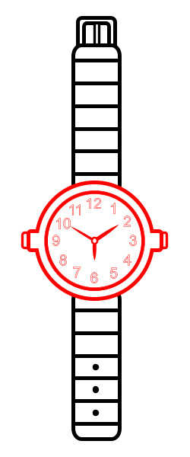**3- Choose the write word under the pictures :**

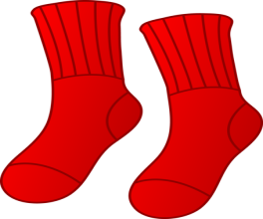

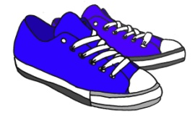

a-( socks – scarf ) b-( ring – watch ) c-( tracksuit- trainers) d-( monitor-mouse pad)





e-( scarf – tie ) f-( headband – sweater )

**4- write the correct words under the write category :**

( monitor – aftershave – ring – bracelet – keyboard – razor blades – tracksuit – golf club )

A – men’s toiletries : ------------------------------ -----------------------------------

b- computers : ------------------------------------ -----------------------------------

c- jewellery :-------------------------------------- -----------------------------------

d- sports :----------------------------------------- -----------------------------------

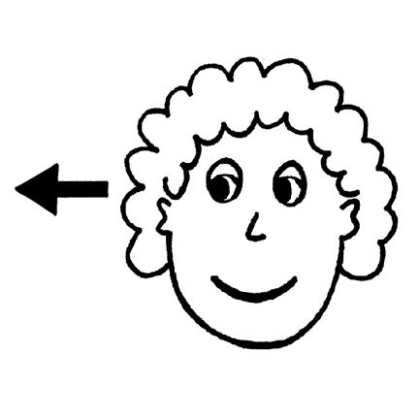5-

**Countable** : many # few **uncountable** : much # little

Any – a lot of – some – most – all – none – neither – all of- both

**Choose the correct answer :**

a- How **( much – many )** people are coming ?

b- **( Both – All )** of my parents are Saudi Arabians

c- Can you answer **( a few – a little )** questions about the history lesson ?

d- There is not **( much – more )** water in the lake

**6- Complete the table , comparing between the urban life and the rural life :**

**Urban life**  **rural life**

1---------------------------------------------------- 1---------------------------------------------------

2---------------------------------------------------- 2---------------------------------------------------

3---------------------------------------------------- 3--------------------------------------------------------

**7- Complete :**

a- We use ------------------------ , ----------------------------- and ----------------------------to

introduce reasons.

b- give reasons for the following sentences :

* I did not go to school yesterday ---------------------------------------------------------------------------------------------------------------------------------------------------------------
* I will travel to Makkah in Ramadan -----------------------------------------------------------------------------------------------------------------------------------------------------------

Prepared by

Teacher Bushra Assiri