**A**

**Name: …………………………………………….............. Class : …………. Mark : /10**

1. Complete the sentences with a phrase from the box below:

source – ocean waves – nuclear power – fossil fuels

1. Oil and coal are both …………………………..
2. ………………………….. produces radioactive waste, which is dangerous.
3. Wind is one of the cleanest and best ………………………….. of energy.
4. Circle the odd word and explain why it doesn't fit:

* windy / tree / sunny / cloudy ………………………………………………….

1. 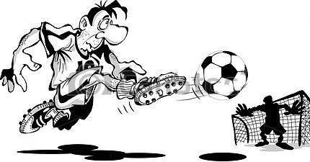Make a sentence about the picture below using ***going to*** and the words in brackets:

( he / score a goal )

…………… ………………………………………………………………………..

………………………………………………………………………..

1. Use the words below to write a conditional sentence with  ***if***.

* we / not / go to match - it / rain

………………………………………………………………………………………………….

1. **Listen** to a nutritionist talking about energy and then answer the questions below:
2. What percentage of energy is used for :
3. eating and digestion? ……………………..%
4. body function? ……………………..%
5. physical activity? ……………………..%
6. Where does our energy come from? ……………………..

**B**

**Name: …………………………………………….............. Class : …………. Mark : /10**

1. Complete the sentences with a phrase from the box below:

renewable – fossil fuels – generator – wind

1. Solar is ………………………….. energy.
2. ………………………….. is one of an electricity- producing machinery.
3. Oil and coal are both …………………………..
4. Circle the odd word and explain why it doesn't fit:

* oil / windmill / gas / coal ………………………………………………….

1. Make a sentence about the picture below using ***going to*** and the words in brackets:

( it / rain )

………………………………………………………………………..

………………………………………………………………………..

1. Use the words below to write a conditional sentence with  ***if***.

* you / eat that cake / - not / eat launch

………………………………………………………………………………………………….

1. **Listen** to a nutritionist talking about energy and then answer the questions below:
2. What percentage of energy is used for :
3. physical activity? …………………….%.
4. eating and digestion? ……………………..%
5. body function? ……………………..%
6. Complete

* our energy comes from …………………… which we get from different type of food.