**wave–shipwreck –jolly Roger- parchute-land**

**By:E.T \ Fatma Elethedy**

**English Landuage Exam#2**

**A)-Write down the correct words :**

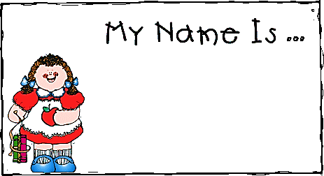[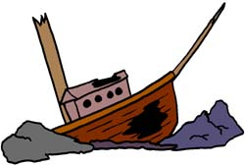](http://www.google.com.sa/url?sa=i&rct=j&q=&esrc=s&frm=1&source=images&cd=&cad=rja&uact=8&docid=eClUTSoOVhFReM&tbnid=lrEjoEwLH33nZM:&ved=0CAUQjRw&url=http://us.bestgraph.com/cliparts/bateaux-3.html&ei=KZFSU6aUJ--R0QWQ_oCADw&psig=AFQjCNHMBBKe_DiLuN1ZftrNp3S3wilFVA&ust=1398006085948315)[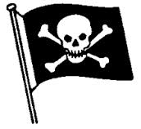](http://www.google.com.sa/url?sa=i&rct=j&q=&esrc=s&frm=1&source=images&cd=&cad=rja&uact=8&docid=IC4_yEXjioDRhM&tbnid=Q8-tDjmgQGWWBM:&ved=0CAUQjRw&url=http://www.mepham.org/pirates.html&ei=54pSU_D_MIea1AX0sID4DA&psig=AFQjCNFzC7iUPFeQ3B_weQTObHXemqYJHg&ust=1398004837500970)[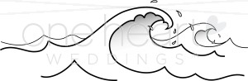](http://www.google.com.sa/url?sa=i&rct=j&q=&esrc=s&frm=1&source=images&cd=&cad=rja&uact=8&docid=wWsUzFpZPVCzrM&tbnid=to_cHPGo57N9iM:&ved=0CAUQjRw&url=http://www.weddingclipart.com/image/waves-clipart.html&ei=f45SU6bKDsax0QXVuoH4Ag&psig=AFQjCNEBUMEfwPL0-ZJ8pLxxajE0F-MXQA&ust=1398005724784167)

I-Reading

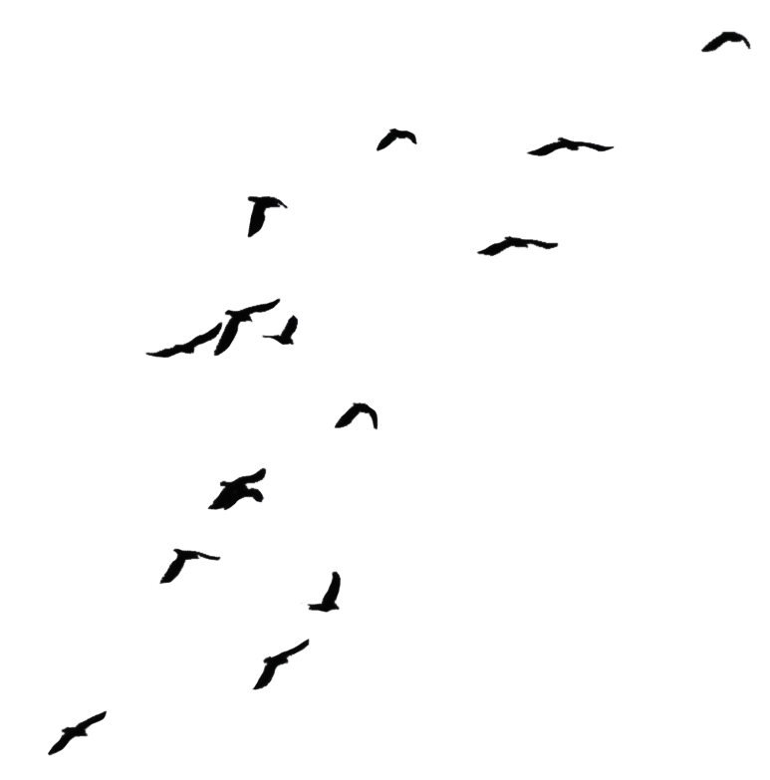[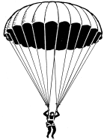](http://www.google.com.sa/url?sa=i&rct=j&q=&esrc=s&frm=1&source=images&cd=&docid=LWPwk3LF2dd34M&tbnid=9Bv_Wobep4srFM:&ved=0CAUQjRw&url=http://www.marysrosaries.com/collaboration/images/a/a8/&ei=holSU-7JJM-X0AWxnYGoBA&psig=AFQjCNHtdiqBofG8OzMKJ1T0tPhA006TcQ&ust=1398004459478210)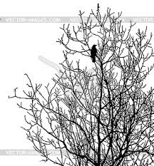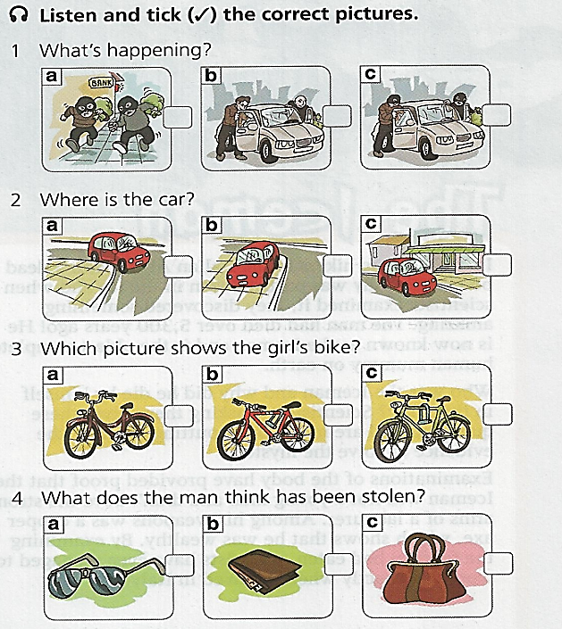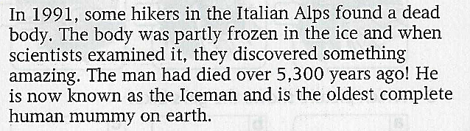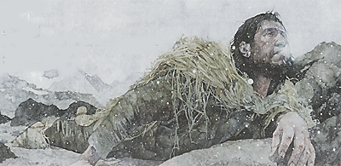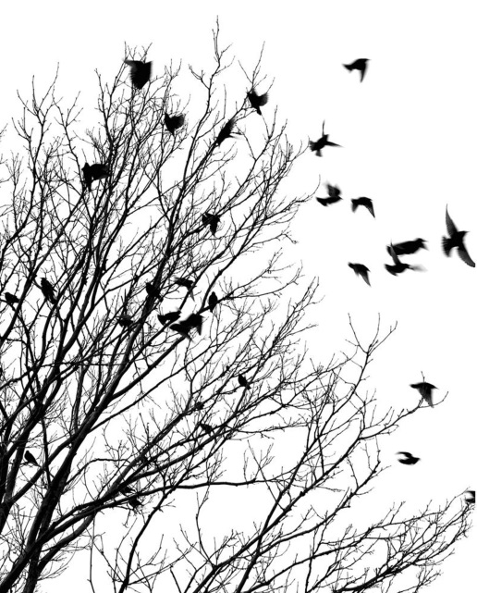

III-Vocabulary

Iv-Grammar

v-Listening

II-Spelling

**B)-Choose :**

2)-If Kareem eats now,it (is –will be)

dangerous for him.

**……**

1)-We were by (myelf – ourelve-herself)

in the house.

**……**

**B)-Choose:**

**……**

**--------**

1)- He wishes he is there at that moment.

……

**A)-Correct:**

**……**

2)- Strength=(power- size)

1)-innocent#(fine–guilty)

**( s – o – c – u – a )**

**1)-s_rf**

**2)-l_w**

**4)-wet_uit**

**3)- hands_uff**

**Fill in the missing letters:**

**What is the died body known as?**

**……**

**Founded by**

**Died over…**

**Where..**

**Founded In**

The Iceman