Name : ____________________ Date : _____________

Class : 4 / ___ لم تتقن أتـقــنــت

No. (28) قياس مهارة Recognize and apply the directionality in writing English (left/right, top/bottom) |  | الفترة الأولى
A.Trace:








No. (29) Use lined paper correctly with headline, midline and baseline  أتـقــنــت لم تتقن | الفترة الأولى
A. Copy the following letters correctly using the four lines :

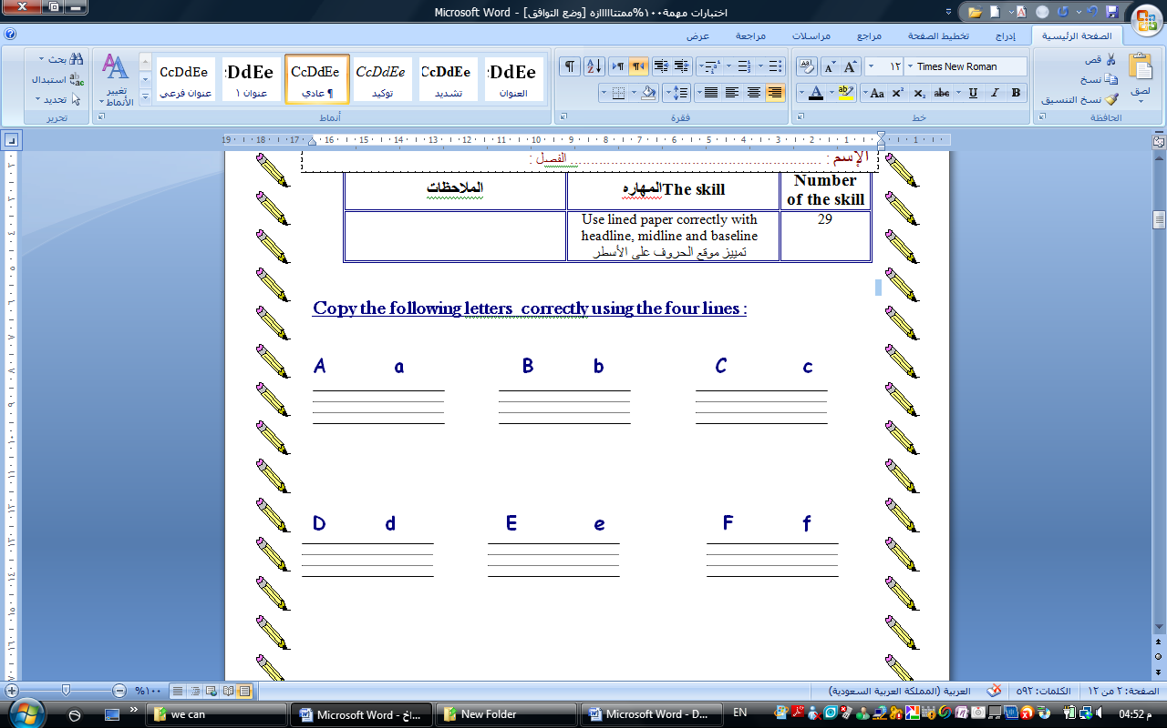

توقيع ولي الأمر : _________________________________ | ملاحظات المعلمة : _______________________________
Name : ____________________ Date : _____________
Class : 4 / ___ لم تتقن أتـقــنــت

No. (21) قياس مهارة Utter simple words and numbers cardinal numbers 1-19 |  | الفترة الأولى
A. Circle the word you hear :
1- duck bear fish

2- cat apple egg
B. Connect the numbers :
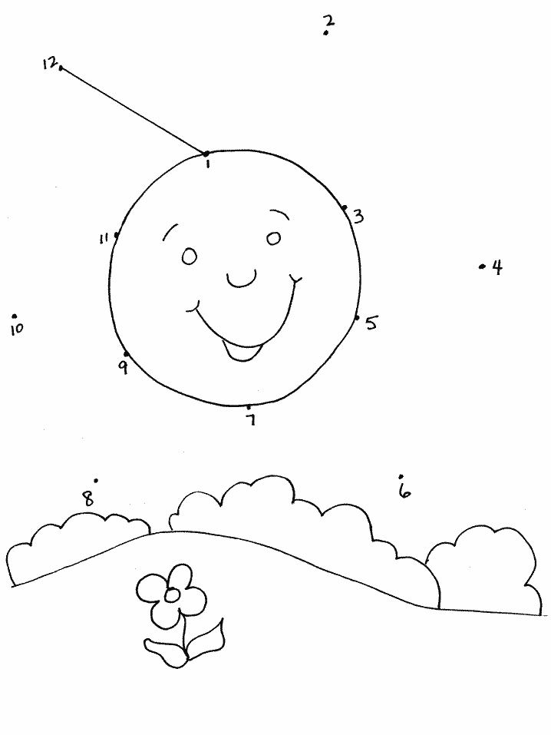

C. Count and write :


= ………… = ……….

============================================================================
رقم المهاره | المهاره | اتقنت | لم تتقن
6 | 6-Participate verbally & non-verbally in short simple activities: greeting, giving and receiving commands.
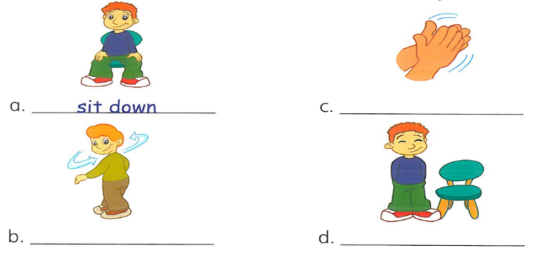
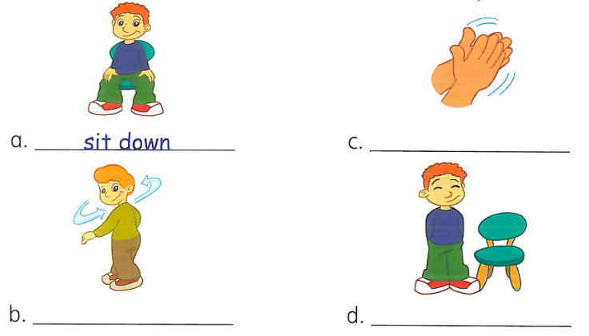
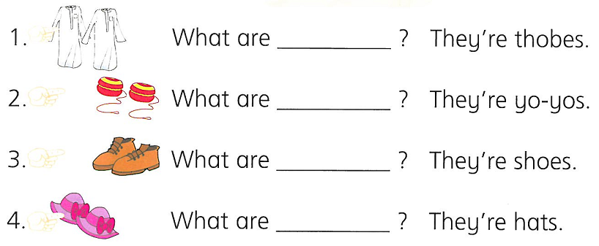
A- Put () or ():
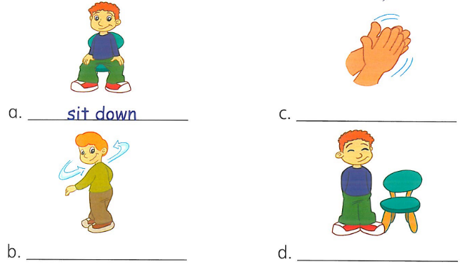

Stand up ( ) - clap your hands ( ) sit down ( )
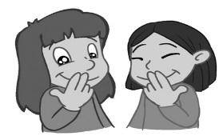
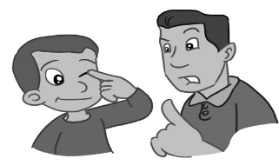
B- Choose the correct answer:

A- B-

1 – Touch your eyes . 1 – Touch your ears .
2 - Touch your toes . 2 – Touch your mouth .

رقم المهارة | وصف المهارة(The Skill ) | أتقنت | لم تتقن
5 * | * Recognize and match sounds to letters
I- circle the sound you hear :
S s
B b
G g
S s
B b
G g
S s
B b
G g

1- 2- 3-

Name : ____________________ Date : _____________14
Class : 4 / ___

رقم المهاره | المهاره | اتقنت | لم تتقن
9 | Ask &respond to basic questions about personal information using verb to be …
- Match the question with the answer
1- What is your name ? Hello .

2- How are you ? My name is Nora.

3- Hello I am fine , thank you.

================================================================

No. (15) قياس مهارة Identify the main colors(red – blue – green – black – white –yellow-brown ) | اتقنت | لم تتقن
A- Colour :
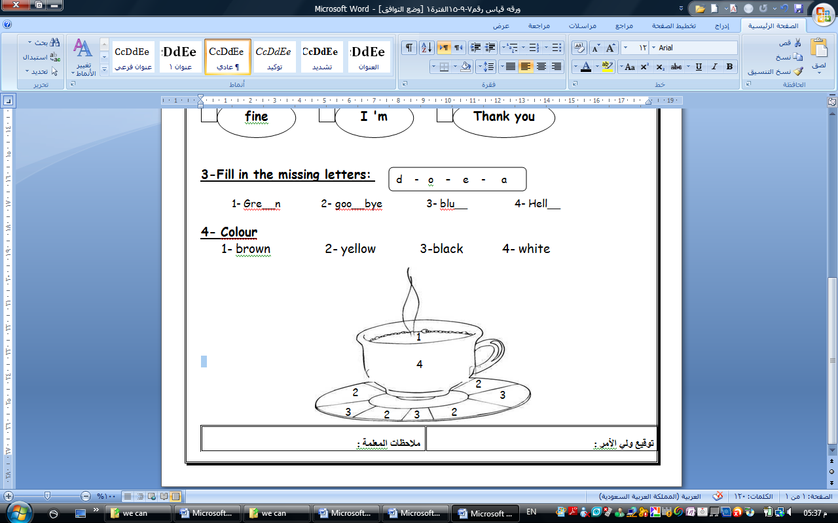
1- brown 2- yellow 3-black 4- white

================================================================
No. (16) Identify and talk about classroom objects which are assigned in the book  أتقنت لم تتقن | الفترة الأولى
Match:-

door
Pen
book

Name : ____________________ Date : _____________14

Class : 4 / ___

رقم  المهارة | وصف المهارة(The Skill ) | أتقنت | لم تتقن
20 | Be willing to listen to short digital and recorded materials.

- Listen and number (1-3).
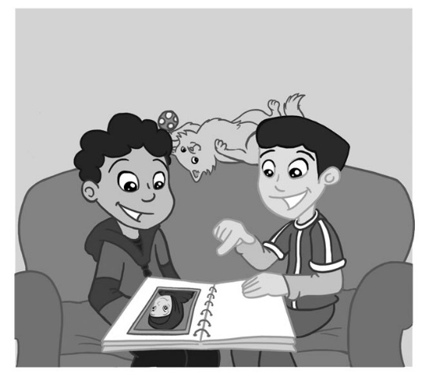
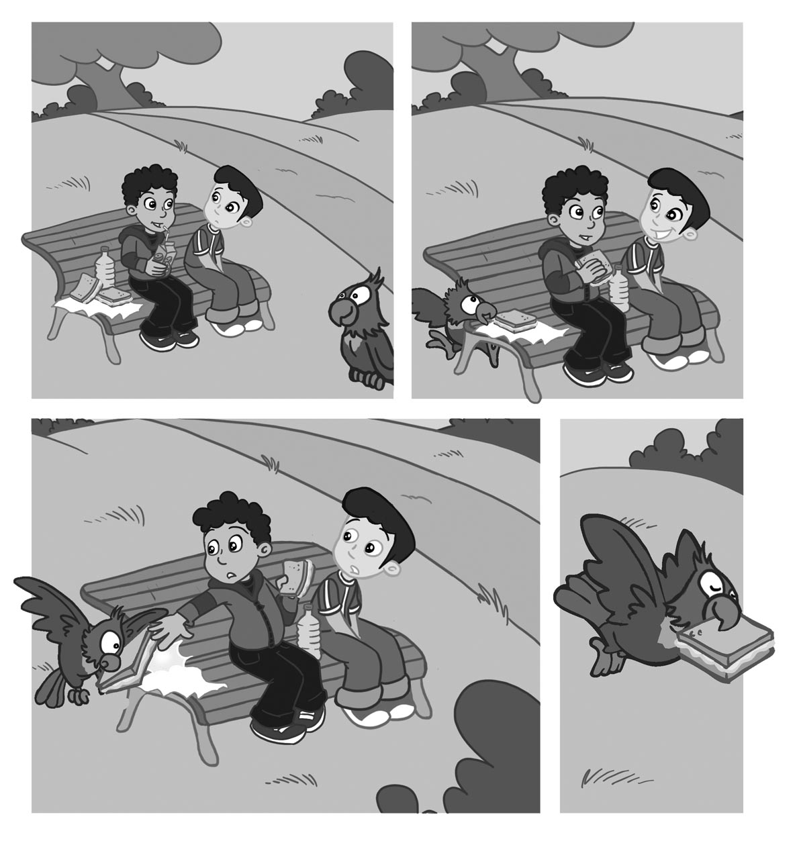
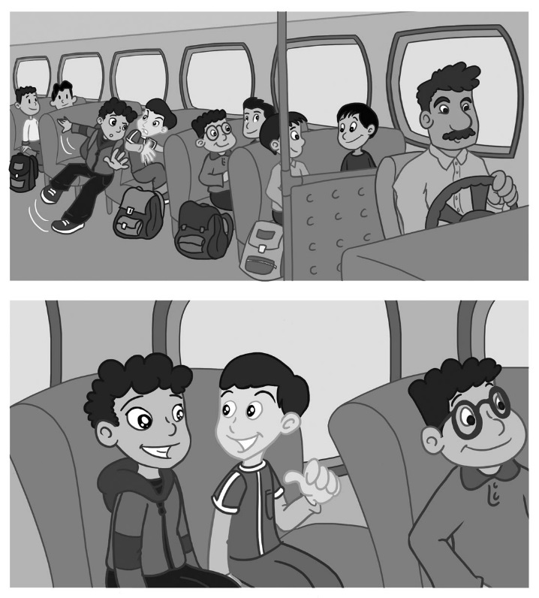

b

c

a

رقم المهاره | المهاره | اتقنت | لم تتقن
34 | Do controlled writing such as supplying missing letters & words

_ write the missing letters:
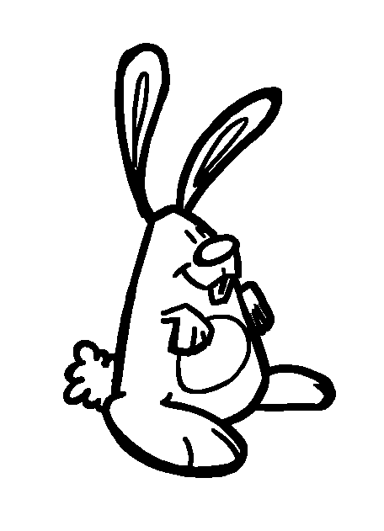
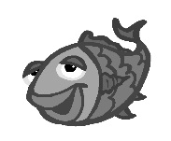
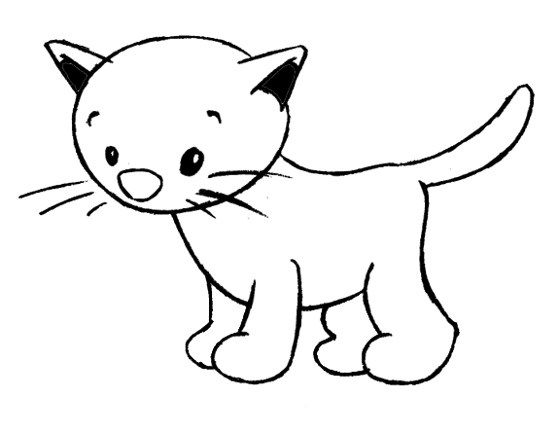

__at __ish __abbit

رقم  المهارة | وصف المهارة(The Skill ) | أتقنت | لم تتقن
10 * | * Recognize and use indefinite articles (a - an) using this, that
3-

choose :
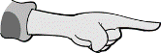
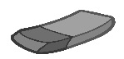

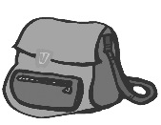

- This is a rubber .
- That is a rubber .
- This is a bag .
- That is a bag .

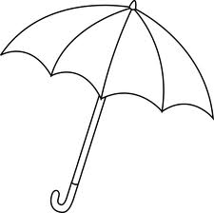
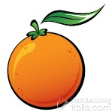
- It's a umbrella .
- It's an umbrella .
- It's a orange .
- It's an orange .

الاسم / ................................................. .......................................... Name :
الصف / رابع / ......
ورقة قياس ( 5 ) – الفترة الاولى

رقم المهارة | وصف المهارة(The Skill ) | أتقنت | لم تتقن
8 | Ask and respond …yes,no questions.
- listen and circle :



.3
.2
.1

Yes No
Yes No
Yes No

رقم المهارة | وصف المهارة(The Skill ) | أتقنت | لم تتقن
11 | Recognize and apply ….. this , that .

Complete with : this - that


- It's an egg .

- It's a bear .

- It's a fish .

- It'a a cat .
1. What's _________?

2. What's _________?

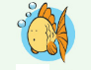
3. What's __________?

4. What's __________?

رقم المهارة | وصف المهارة(The Skill ) | أتقنت | لم تتقن
30 | Copy words …..
Copy :

الاسم / ................................................. .......................................... Name :
الصف / رابع / ......
ورقة قياس ( 6 ) – الفترة الاولى

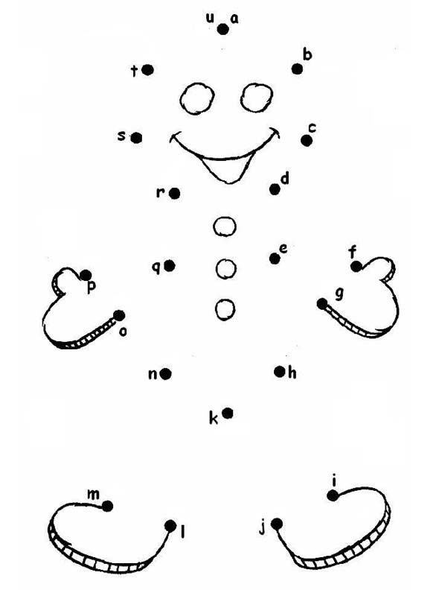
رقم المهارة | وصف المهارة(The Skill ) | أتقنت | لم تتقن
1 | Recognize and produce the sounds af the English alphabet .

رقم المهارة | وصف المهارة(The Skill ) | أتقنت | لم تتقن
12 | Recognize and apply subjective pronouns correctly .( I )
Complete :
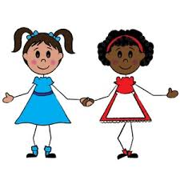
______ fine .
Thank you .
Hello .
How are you ?

رقم المهارة | وصف المهارة(The Skill ) | أتقنت | لم تتقن
31 | Write upper & lower case letters correctly .
Copy :

