**Unit : 1 ( Greeting ) Lesson: 1 Date: /11/1435H**

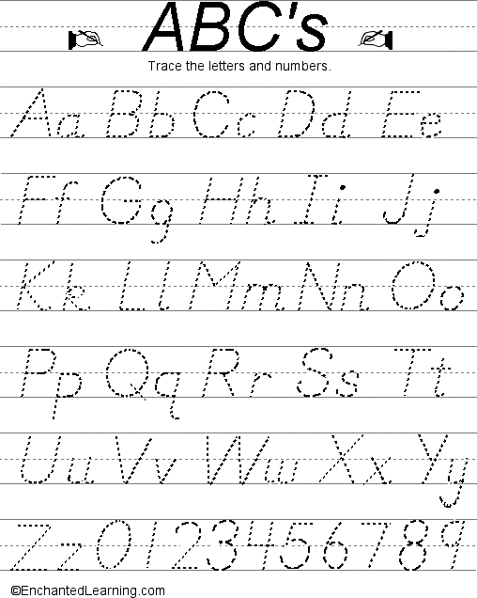

**1- Answer the following questions in complete answers :**

A) What is your name ?

B) How are you?

**Complete:**

Hi , I am Sarah, What is your**…..…..…**.?

I

I'm ………………,thanks .

…………..……., thank you. …………are you ?

My………..…….is Helen, How ………..you ?

|  |  |
| --- | --- |
| **1- Choose the correct greeting ( answer) :** | |
| **How are you?** | **Hello ! I’m Sammy.** |
| a- Hi. | a- Bye |
| b- Good morning. | b- Hello. I’m Adel . |
| c- I'm fine, thanks | c- I am fine . |
| **Good bye!** | Good morning. |
| a- Bye . | a- Good morning. |
| b- Good afternoon. | b- Good night. |
| c- Good night. | c- Good evening. |

**Unit : 2 ( My Family ) Lesson: 1 -2 Date: /11/1435H**





New words:

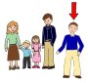

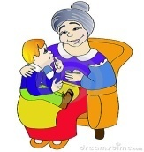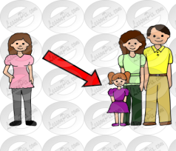



**Grammer:**

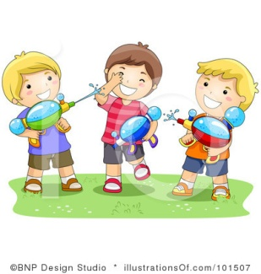



**Answer :**

a)**How old are you?**

b) **How old is he?**

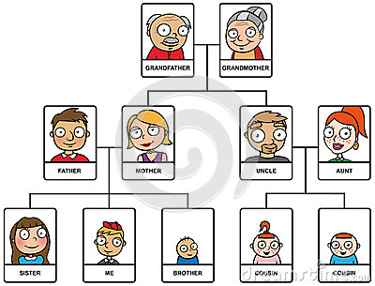

1. **Put ( This / These ) , the pictures will help you:**

**[](http://schools-demo.clipart.com/search/close-up?oid=3918141&q=desk&s=1&a=c&cid=&k_mode=all&k_exc=&q_jpeg=1&q_gif=1&q_color=1&q_bw=1&q_eps=1&q_wmf=1&q_psd=1&q_png=1&date=&pubid=&isadv=1)**

[http://images.clipart.com/thm/thm6/CL/freeze_006b/6_hands/hand41.thm.gif](http://schools-demo.clipart.com/search/close-up?oid=2798335&q=finger%20pointing&s=1&a=c&cid=&k_mode=all&k_exc=&q_jpeg=1&q_gif=1&q_color=1&q_bw=1&q_eps=1&q_wmf=1&q_psd=1&q_png=1&date=&pubid=&isadv=1)

1. ________ is a desk.

[](http://schools-demo.clipart.com/search/close-up?oid=3780975&q=boys&s=1&a=c&cid=&k_mode=all&k_exc=&q_jpeg=1&q_gif=1&q_color=1&q_bw=1&q_eps=1&q_wmf=1&q_psd=1&q_png=1&date=&pubid=&isadv=1)[http://images.clipart.com/thm/thm6/CL/freeze_006b/6_hands/hand41.thm.gif](http://schools-demo.clipart.com/search/close-up?oid=2798335&q=finger%20pointing&s=1&a=c&cid=&k_mode=all&k_exc=&q_jpeg=1&q_gif=1&q_color=1&q_bw=1&q_eps=1&q_wmf=1&q_psd=1&q_png=1&date=&pubid=&isadv=1)

1. _______ are my cousins .

MCj04241580000[1]

1. [http://images.clipart.com/thm/thm6/CL/freeze_006b/6_hands/hand41.thm.gif](http://schools-demo.clipart.com/search/close-up?oid=2798335&q=finger%20pointing&s=1&a=c&cid=&k_mode=all&k_exc=&q_jpeg=1&q_gif=1&q_color=1&q_bw=1&q_eps=1&q_wmf=1&q_psd=1&q_png=1&date=&pubid=&isadv=1)_______ is Layla
2. **Choose:**
3. ( His – Her ) name is Amal
4. His name is ( Sarh – Fahad)