**Match the correct word with pictures : B-**

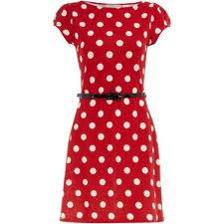 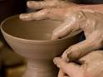 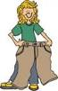 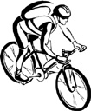

**A-Choose the correct answer :-**

1-He is ( play - plays - playing ) basketball at the moment.

2-Hassan can run ( faster - fast - the fastest ) than Amen.

3-(Everyone - Everywhere -Nowhere) in my class like History.

4- My sister didn't ( use - used - using ) computer .

5-Ahmad is the most active ( as - of - than ) all my classmate

-------------------------------------------------------------------------

**A-Do as shown between brackets :-**

3-Fatimah is ( **go** ) shopping tomorrow. ( *Correct the verb*)

…………………………………………………………………………………..

**A-Fill in the missing letter:-**

1- She wants to try something new and **ta…..le tennis**

2- My favorite sport is **ae…..obics**

3- **Colla…..e** is akind of art .

4- She wears **stri……ed** dress .

Makkah o'cluck tower is a landmark

Name/ class / 3 -

**1-Read then answer the following questions:**

Jeans are trousers made of denim. Most of people have at least one pair, and in the USA an average person has seven pairs. The word jeans comes from French.

In 1850s , a German merchant started selling jeans to mine workers in California. They became popular because denim is very strong material . After that, more and more designs and styles came out, like baggy jeans and even stonewashed jeans that looked old. Other clothes go in and out of fashion , but jeans are here to stay.

***1) What are jeans made of ?***

……………………………………………………………………………

***2) Which type of jeans looks old ?***

…………………………………………………………………………………..

3) **Are jeans trousers ?**

…………………………………………………………………………………..

***3-) Put ( T ) or ( F ) :***

a-In the USA an average person has three pairs ( ).

b-The word jeans comes from Germany ( )

4-Complete:-

clothes go in and out of fashion , but…………………………………………

-------------------------------------------------------------

**A-Choose the correct word:**

1- What are you up to ?

a- how are you ? b- where are you c- What are you doing ?

2- …………………………. is surfing in the sky

a- Athletic b- sky surfing c- mountain

3- I am **interested in** reading ( fond of means )…..

a- dislike b- don't like c- like

4-Kareem is …………………..person so he is never nervous about anything .

a- outgoing b- confident c- bossy

5- Do you ………………going to the park ?

a-fancy b- get c- lost

Mountain biking - pottery - spotted - baggy

------------------------------------------------------------------------------------------------------------------------------------------------------------------------------

**Good luck**