**Distribution of the Syllabus For** 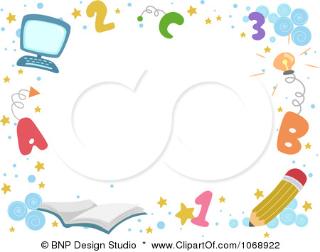

**fourth Grade second Term 1436 – 1437**

|  |  |  |  |  |  |
| --- | --- | --- | --- | --- | --- |
| 6th week | 5th week | 4th week | 3rd week | 2nd week | 1st week |
| **12 / 5 – 16 / 5** | **5 / 5 – 9 / 5** | 28/ 4 – 2 / 5 | 21 / 4 – 25 / 4 | 14 / 4 –18 / 4 | **7 / 4 –11/ 4** |
| Unit 3  Talk time  Rhythms & sounds | Unit 2  Phonics  **evaluation** | Unit 2  Rhythms & sounds  Words | **evaluation**  Unit 2  Talk time | Unit 1  Words  Phonics | Unit 1  Talk time  Rhythms & sounds |
| 12th week | 11th week | 10th week | 9th week | 8th week | 7th week |
| 2 / 7 – 6/ 7 | 25 / 6 – 29/ 6 | 18/ 6 – 22/ 6 | **11 / 6 – 15 / 6** | **26 / 5 – 1 / 6** | **/ 5 – 23 / 5219** |
| Unit 5  Words  Phonics | Unit 5  Talk time  Rhythms & sounds | Unit 4  Phonics  **evaluation** | Unit 4  Rhythms & sounds  Words | **evaluation**  Unit 4  Talk time | Unit 3  Words  Phonics |
| 18th week | 17th week | 16th week | 15th week | 14th week | 13th week |
| **15 / 8 – 19 / 8** | **8 / 8 – 12 / 8** | **1 / 8 – 5 / 8** | 23 / 7 – 27 /7 | 16 / 7 – 20 / 7 | 9 / 7 – 13 / 7 |
| **The Final**  **Exams** | **The Final**  **Exams** | **Revisions** | **Phonic Practice** | **evaluation**  **Work Sheet** | Unit 5  Words  Phonics |

**التوقيع :**

**التوقيع :**

**مشرف/ة المادة : أ**

**معلم / ة المادة**

**مدير/ ة المدرسة :أ.**

**التوقيع :**