][\English exam

Fourth grade

Name……………………………………………………….. class………………

**1- Count and write :**

…………………… ……………........ …………………..

**2- Colour the following shapes :**

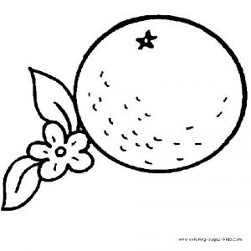 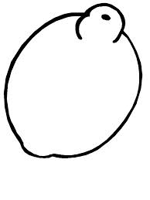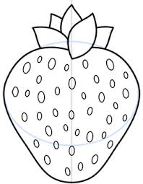

Red Orange Yellow

**3- Match the words to their pictures:**

Mother 

 Pen  Bed Table 

**4- Write the letters you hear :**





**5- put a or an :**

………..chair.

………… pencil.

…………. Orange.

Good luck