 **New words:**

***Date :----------------------------------------***



***1-be late***

***2-borrow***

***3-chocolate bar***

***4-junk food***

***5-try***

|  |  |  |  |
| --- | --- | --- | --- |
| *Nationalities* | *Countries* | *Nationalities* | Countries |
| *Mexican* | ***Mexico*** | ***Chinese*** | ***China*** |
| *Moroccan* | ***Morocco*** | ***Cuban*** | ***Cuba*** |
| *Peruvian* | ***Peru*** | ***Egyptian*** | ***Egypt*** |
| *Saudi* | ***Saudi Arabia*** | ***Greek*** | ***Greece*** |
| *Thi* | ***Thiland*** | ***Italian*** | ***Italy*** |
| *Emirati* | ***Emirates*** | ***Jordanian*** | ***Jordan*** |

*Grammar*:

***How much and How many :***

***1-We use how much with uncountable nouns like water , sugar***

***2-We use how many with countable nouns such as apples , eggs***

***نستخدم how much مع الأسماء غير المعدودة وhow many مع الأسماء المعدودة***

Date:------------------------------------

*school subject New words:*

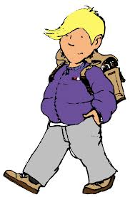

***1-Art 6-ICT***

***2-Biology 7-Maths***

***3-Chemistry 8-PE***

***4-Geography 9-physics***

***5- History***

*1-also 8-sailing*

*2-before 9-start*

*3-after 10-science lab*

*4-facilities 11- till*

*5-finish 12-untill*

*6- gym 13- want*

*7-perfect 14-paint*



***Present simple المضــارع البسيط***

***He , she , it , + verb we add ( s ) to the verb***

***eg : he drinks milk***

***وعند تكوين سؤال بنعم او لا في زمن المضارع البسيط نقوم بعمل الأتي***

***أولا نضع Does والضمائر التي تأتي معها هي she , he , it أو Do والضمائر التي تأتي معها هي they , we , you , Iثم نضع الضمير ثم الفعل وتكملة السؤال مثال***

***1-Do you speak English ?***

***2-Does she speak English?***

***ملاحظه :1- عند تكوين السؤال لانضع (S ) للفعل مع he , she , it لكن فقط في الإجابة والجملة***

***2-عند النفي نضيف not لــ Does و Do فتصبح Don't و Doesn't***

***Wh Q أدوات السؤال***

***ويسأل فيها عن شخص 4-Who ويسأل فيها عن شيء 1- What***

***ويسأل فيها عن الكيفية 5- How ويسأل فيها عن الزمان 2- When***

***ويسأل فيها عن المكان 3- Where***

***عند تكوين سؤال معلومات في زمن المضارع البسيط أولا نضع أداة السؤال ثم Does أو Do ثم الضمير ثم الفعل .***

***Wh Q + Does , Do + S + verb ------------?***

***1-Where does he go ? 2- Where do you go ?***

***Answer the following questions:-***

***a- What is your name?***

*...........................................................................................................*

***b-How old are you?***

*..........................................................................................................*

***c-Which school do you go to?***

*...........................................................................................................*

***d-What are the facilities in your school ?***

*...................................................................................................................................................... .*

***e- ( ICT ) & ( PE ) what does it mean ?***

*………………………………………………………………………………………*



***- Complete with the present simple:-***

***a- Sara ………………….(cook) the lunch every weekend.***

***b-The boys …………………(play)football every Friday.***

***c-……………………..Ahmad read books?***

***d- I eat breakfast. 🡺negative:……………………………***



***1- Match the following words with the pictures;-***

*a- Math b- chemistry c- PE d-history*

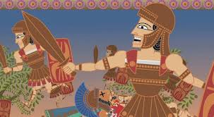 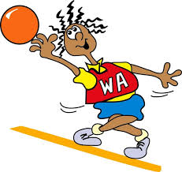 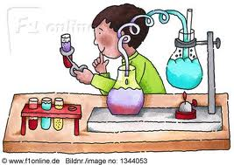

*---------------------- ---------------------- ---------------------------*

**

DATE: …………………………………..

***New words Appliances***

*1-boring 6-headache*

*2-brush 7-rubbish bin*

*3- carpet 8-sponge*

*4-change 9-tired*

*5-electric 10- tooth brush*

*-*

*1-Cooker 4-hoover*

*2-dishwasher 5-iron*

*3-fridge 6-washing machine*



*Adverb of frequency*

***1-always 2-usually 3-often 4-some time 5-never***

*نضعها إما :*

1. *قبل الفعل الرئيسي 1-before the main verb*
2. *بعد الأفعال المساعدة 2-after the verb ( be )*

*Rewrite the sentence using the adverbs of frequency in brackets :*

*1-Frank watches TV after work ( never )*

*…………………………………………………………………………………………………………..*

*2-I don't get up at 7 O'clock . ( often )*

*…………………………………………………………………………………………………………….*

*3-Maria cooks dinner on Wednesdays . ( sometimes )*

*…………………………………………………………………………………………………………….*

***1- Match the following words with the pictures;-***

*Iron cooker dishwasher fridge hoover*

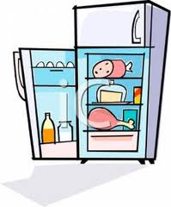 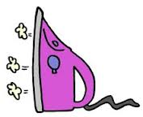 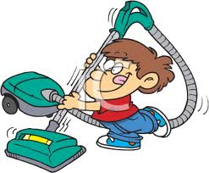 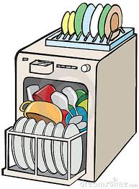

................. .................. ..................... .....................

Date:………………………………………………





***New words Clothes and accessories***

*1-abaya 7-jumper*

*2-belt 8-leggings*

*3-boots 9-sandals*

*4-earrings 10- shirt*

*5-hat 11-tracksuit*

*6-headscarf 12-skirt*

***1-bored 6-patch***

***2-decorate 7- pocket***

***3-draw 8-ugly***

***4-in fashion 9- wait***

***5-look like 10-look for***





***Present progressive المضـــارع المستمر***

ويستخدم لأفعال حدثت الآن أو حالة مؤقتة وطريقة تكوين جملة في زمن المضارع المستمر بإستخدام Am , is , are ثم الفعل ثم بأضافة ing للفعل

|  |  |  |  |
| --- | --- | --- | --- |
|  |  | *Am* | *I* |
| Ing | Verb | ***Is*** | *He , she , it* |
|  |  | ***Are*** | *You , we , they* |

***مثال I am drawing a picture***

***وفي حالة النفي في زمن المضارع المستمر نضيف not بعد الأفعال المساعدة am , is , are***

***مثال : I am not drawing a picture***

***وعند تكوين سؤال بنعم أولا في زمن المضارع المستمر نقوم بعمل الأتي:***

|  |  |  |
| --- | --- | --- |
|  | ***I*** | ***Am*** |
| ***V + ing*** | ***He , she , it*** | ***Is*** |
|  | ***You , we , they*** | ***Are*** |

***مثال : ِAm I drawing ?***

*Complete the sentences with the words in the box:*

*Draw fashion earrings ugly pockets cut*

*1-I don't like that hat it's ------------------*

*2-Let's ------------------- a flower on my top*

*3-My jeans haven't got ----------------*

*4-leggings are in ---------------- this winter. *



***Make yes / No Questions***

*1-Tom is going out with his friends. -------------------------------------------------------- 2-tim & Mark are playing football. ----------------------------------------------------------*

**

Date :……………………………………………

***Free- time activities New words:***

*1-Chat on the phone*

*2-do arts and crafts*

*3-download information from the net*

*4-go rollerblading*

*5-go skateboarding*

*6-hang out with friends*

*7- read magazine / newspaper*

*8-play table tennis*

*9-surf the net*

*1-bat 6-join*

*2-can't stand 7-knee pad*

*3-competition 8-web site*

*4-elbow pad 9-take part in*

*5- group 10- winner*



*Like / love / enjoy / hate / can't stand + ing form or noun*

*2- would like / want + to or noun*

*نستخدم Like + ing لنعبر عما يعجبنا بشكل عام مثال I like going shopping*

*نستخدم would like to لنعبر فيها عما نريد أن نفعله ولتقديم عرض أو طلب و دعوة*

*مثال would you like to play tennis with me*

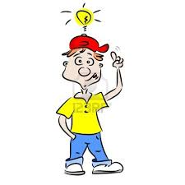

***Complete with the sentences :***

*1-Check out this flyer*

*2-it looks good*

*3-What does the winner get*

*4- we can join*

*Paul : Hey Mark . What are you doing ?*

*Mark:…………………….there's a new table tennis club in town .*

*Paul: look ………………. All ages are welcome.*

*Mark : What do you think*

*Paul:----------------------------let's join . I'm good at table tennis.*

*Mark: OK. Why not? There's a tournament on Saturday.*

*Paul:………………………………………….*

*Mark :Two new bats.*

*Paul: That's great.*



***Circle the correct words :***

*1-I enjoy { play / playing } table tennis with my friends .*

*2-Andy wants { join / to join } an ice-hockey team.*

*3-My mother can't stand { wearing / to wear }*

*4-I'd like { making / to make } my own clothes*

Date:……………………………………………….



**

***.New words personality Appearance***

*1-active 2-clever*

*3-friendly 4-helpful*

*5-lazy 6-outgoing*

*7-shy 8-unfriendly*

1-Chubby 2-Curly

*3-dark 4-fair*

*5-good-looking*

*6-slim 7-straight*

*8-medium-length*

*9-wavy*

***Give the opposite :***

1-friendly:…………………… 2-Shy:…………………….. 3-active…………………

4-slim:………………………. 5-curly:………………….. 6-short:…………………..



*Word order ترتيب الكلمة*

*1-sbject + verb + Object فاعل + فعل + مفعول*

*مثال : We read magazines*

*ثانياً : صفة + الأسم Adjective + noun*

*مثال : She's a beautiful baby*

*ثالثاً:Verb be + adjective*

*مثــــال: This baby is beautiful*

***Answer the following questions:***

*1-Who is your best friend?*

*……………………………………………………………………..*

*2-What does she look like?*

*……………………………………………………………………….*

*3- What do you do in your free time ?*

*……………………………………………………………………….*

*What is she like ?*

*………………………………………………………………………*



Make sentence by putting the words in the correct order:

*1-plays / William / every day / table tennis .*

…………………………………………………………………………

*2-man / active / an / is / Mr Smith*

*……………………………………………………………………………….*

*3-Mark / got / hair / has / wavy*

*…………………………………………………………………………………….*

*4-skirt / ugly / that / is*

*………………………………………………………………………………….*



***Writing :***

*1-Write three adjective describing personality :*

*………………………………………………………………………………………………………………*

*2-write three adjectives describing physical appearance :*

*……………………………………………………………………………………………………………….*



***New words: Holiday activities***

*1-buy souvenirs*

*2-explore a cave*

*3-go hiking*

*4-go horse riding*

*5-go on a cruise*

*6-go on a trip*

*7-go sightseeing*

*8-travel abroad*

1-almost 7-desert

*2-around 8-fall of*

*3-be back 9-guys*

*4- camel 10-manage*

*5-experience*

*6-forget 11- scared*

***Past simple الماضي البسيط***

*عند تكوين جملة في زمن المضارع البسيط نضع الضمير ثم الفعل في الماضي مثال : I went to the mall*

*وفي حالة النفي نضع did not ثم الفعل مباشرة ولكن الفعل الأصلي بدون اضافات مثال: I didn't go to the mall*

*وعند تكوين سؤال بنعم أو لا في زمن الماضي البسيط نقوم بعمل الأتي أولاً نضع Did ثم الضمير ثم الفعل الأصلي*

*مثال : Did she go to the mall*

*الفعل الماضي is . are , هو was , were*

***Complete the sentence with the words in the box:***

***Forget / desert / sightseeing / fell / experience / scared / show***

*1-Harry saw a Camel in the ……………….*

*2-………………us the pictures from your holiday*

*3-Don't …………….to take your jacket .it's cold outside.*

*4-I was ………………when I tried to ride a horse.*

*5-Steve almost …………………. Off his bike.*

*6-My holiday in China was a great…………………….*



*Complete with the past simple of the verb { be }*

*A:Where ………………….you last night . Paul.*

*B:I……………….at home with John .we watched a documentary about spiders.*

*A:……………….it scary ?Frank saw it too and that's what he told me.*

*B:No,it ………………………. It ………………..really boring !*



***Means of transport New words***

***1-Careful 8-fast***

***2-cheap 9-get off***

***3-crowded 10-hard***

***4-dangerous 11-late***

***5-decide 12-polite***

***6-early 13-popular***

***7-expensive 14- terrible***

*1-ferry 4-underground*

*2-hellcopter 5-tram*

*3-motorbike 6-van*

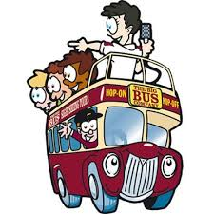

***الفعل Could***

*Could بمعنى يستطيع هو الفعل الماضي لــ Can وتستخدم للتعبير عن القدرة و الإستطاعة في الزمن الماضي*

*مثال My brother could swim when he was seven*

*وعند تكوين سؤال بنعم أو لا بـــ could أولاً نضع Could ثم الضمير ثم الفعل مثال*

*Could he swim ?*

***Write the adverbs***

*1-nice:……………………………… 6-easy:……………………………….*

*2-happy:………………………….. 7-slow:…………………………………*

*3-fast:…………………………….. 8-hard:…………………………………*

*4-terrible:………………………… 9-good:…………………………........*

*5-careful:…………………………. 10-beautiful:…………………………..*

***Complete the sentence with can , could , can't or couldn't***

*A:How many language …………………… you speak.*

*B:only English.*

*2-I ……………………….. swim three years ago . but now I can*

*3-…………………………… you ride a bike when you were five years old?*

*4-When she was two . my sister……………………………..talk but I could.*

*5-………………………….. you cook Chinese food ?*

*B:No, I …………………….. But I can cook Mexican food.*

**Circle the correct words**

*1-the underground is always* ***crowded / Cheap*** *in the morning.*

*2-Mary is very*  ***popular / terrible***  *sh's got many friends.*

*3-Mario is never*  ***late / later*** *for school.*

*4-I don't want to take the ferry . it's very* ***slow / expensive*** *and I want to be there early*

Date:…………………………………………..

***New words***

*1-Caravan 8-merchant*

*2-carry 9-tradition*

*3-connect 10-operate*

*4-donkey 11-route*

*5-goods 12-silk*

*6-item 13-spread*

*7-leave 14-trade*



*Read the sentence below and replace the phrases in brackets with the words / phrases in the box*

***At the age of - in the past - for this reason - long***

*1-they didn't have the T-shirt in red and* ***{ that is why }*** *I didn't buy it*

*…………………………………………………………………………………………….*

*2Alexander the great died*  ***{ When he was }*** *thirty- three*

*…………………………………………………………………………………………….*

*3-it was very cold outside so we didn't stay* ***{ for a long time*** *}*

*……………………………………………………………………………………………*

*4-* ***{ some years ago }*** *I liked rollerblading. Now I think it's boring*

*…………………………………………………………………………………………….*



Date:…………………………………………….

***point of the compass***

*1-actually 8-incredible*

*2-captain 9-land*

*3-coast 10-pleased*

*4-excited 11-promise*

*5-explorer 12-reach*

*6-famous 13-sailor*

*7-immediately 14-shout*

*15-voyage*

*north*

***east west***

*south*

|  |  |
| --- | --- |
| Me | I |
| you | You |
| him | He |
| her | She |
| It | It |
| Us | We |
| You | You |
| Them | They |







***Circle the correct words:***

*1-the { explorer / captain } of the ship was a polite man.*

*2-they got off the ferry { actually / immediately }*

*3-Annie { shouted / promised } to do the washing up.*

*Complete with object pronouns to refer to the words in brackets :*

*1-{ He } is talking to you listen to --------------*

*2- {Tina } is my best friend. I love --------------*

*3- { I } asked my brother to help -------------- with my home work but he didn't .*

*4- I never { go camping } . I hate --------------*

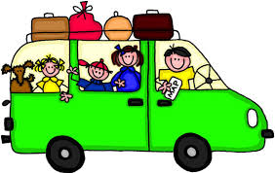

Date:………………………………….

***New words adjectives expressing opinion :***

*1-dinosaur 5-journey*

*2-experiment 6-arrive*

*3-hope 4-invention*

-

*1-amazing 7-interesting*

*2-awful 8-frightening*

*3-brilliant 9-horrible*

*4-cool 10-wonderful*

*5-exciting 11- weird*

*6-fantastic*



*Match:*

*1-Explore ---hiking*

*2-go on ---a trip*

*3- do ---souvenirs*

*4-buy ---a cave*

*5-go ---an experiment*



**Circle the correct words:**

*1-We went to the restaurant { by / on } foot*

*2-A: yesterday at school we did a brilliant { experiment / invention }*

*B : Wow , that's { cool / horrible }*

*3-The sailors were very { crowded / excited } when they reached the coast*

*4- the { trip / voyage } to the museum was interesting*

*5-it's a good thing to keep family { networks / traditions }*

*6-in the past, a bridge { connected / carried } the two countries .*

***Complete the sentences with the adjectives below***

*Dangerous / expensive / fast / crowded / popular*

*1-When something isn't cheap it's …………………..*

*2-When something isn't slow , it's …………………..*

*3-When lots of people like something , it's ………………..*

*4-When there are lots of people in a place , it's………………..*

*5-When something isn't safe, it's ……………………*

Date:………………………………………





***New words parts of the body verb related to accidents***

1-ambulance 6-strange

*2-banana skin 7-suddenly*

*3-exactly 8-pavement*

*4-explain 9-just*

*5-lie*

***1-bleed 5-hit***

***2-break 6-hurt***

***3-crash into 7-slip***

***4-fall down 8-sprain***



***Past progressive الماضي المستمر***

***نستخدم الماضي المستمر لفعل أو حدث حصل في وقت محدد في الماضي 0 مثال على ذلك***

*I was watching TV at seven o'clock yesterday evening كنت أشاهد التلفاز الساعة السابعة مساء الأمس*

*وطريقة تكوين جملة في الزمن الماضي المستمر عبارة عن أولا الضمير يتبعه was , were ثم الفعل ثم ing مثال:*

***\*he was eating *they were eating***

***وعند تكوين سؤال بنعم أو لا في الزمن الماضي البسيط نقوم بعمل الأتي***

|  |  |  |  |
| --- | --- | --- | --- |
| *Ing* | *Verb* | *I , he ,she , it* | *Was* |
| *Ing* | ***Verb*** | ***You , they , we*** | ***Were*** |

***Look at the pictures and write what happened to these people yesterday***

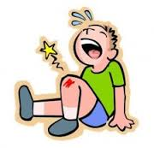 …………………………………………………….

Break

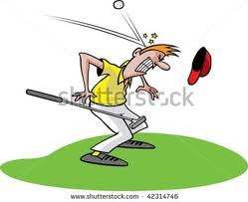 ………………………………………………………………….

Hit

 ……………………………………………………….

hurt

***Complete with the past progressive of the verb in brackets:***

***1-I ……………………….. { download } some information from the internet.***

***2-last night Abdullah …………………… …. { not study } for the test. He …………………………….. { play } computer games .***

***3-What ……………… you ……………….. { do } last night?***

***4-We …………………………… { watch }football on TV.***

***5-Rob and Alex …………………………….. { talk } on the phone all afternoon.***

***6-the cat …................................. { not sit } on the sofa***



***Complete the sentence with the words in the box:***

*Slipped / middle / ambulance / crashed / explain / bleeding / accident / jumped*

***1-the was standing in the ………………….. of the room .***

***2-Saleh……………………and fell down the stairs .***

***3-Alex …………………..off a chair and broke his leg.***

***4-They called for an …………………..and it took Hatim to hospital .***

***5-Oh no! your nose is …………………. What Happened?***

***6-Nouf's father had a car ……………………yesterday. He ………………….into a wall.***

***7-Can you ……………………this to me ? I don't understand .***



***New words***

1-brush 8-footprint

*2-Calm 9-frightened*

*3-Campsite 10-hole*

*4-Chase 11- huge*

*5-Cliff 12-organise*

*6-dark 13-scream*

*7-shadow 14-wild*