الاســــــــــم:----------------------------------------------- ثاني:--------------------

*Answer the following questions:*

*A-Choose:*

*1-(Not to- Don't – Doesn't) come by car.*

*2-You(have to-don't have to) bring an umbrella, I can lend you one.*

*3-I have two sisters. (Both- neither ) of my sisters are in university.*

*4-Can you answer(a few- a little) questions about washing powder?*

*5-I met my best friend( before-while) registering for a karate class.*

*6-I have (a little- a few) money.*

*B-Do as shown between brackets:*

*1-plastic/ black/ a/ jacket (Put the words in the correct order)*

*-------------------------------------------------------------------------------------------*

*2-gold/ small/ a/ pair/ earrings/ of*

*-------------------------------------------------------------------------------------------*

*3-I don't need to tell my parents if I'm coming home late. (Correct)*

*-----------------------------------------------------------------------------------------*

*4-Tick ( ) the correct sentence:*

*There's a lot of food in the refrigerator.( )*

*There's much food in the refrigerator.( )*

*\*\*\**

*We need leave now.( )*

*We need to leave now.( )*

*5-Crossing the road when you come out of the station.(Correct)*

*------------------------------------------------------------------------------------------*

*6-(Complete and put the verb in correct form):*

*Since ------------------(leave) school today, I had a nice surprise.*

*7-(Complete):*

*(groom-degree-graduate-engagement-bride)*

*Graduation:---------------------------------------------------------------------*

*8-Match the article of clothing to this picture:*

*(shirt- sunglasses-trainers- hat- sweater)*

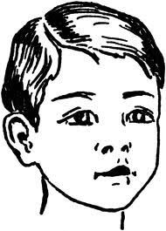

*------------------------------------------------------------------------*

*9-Match the words with correct examples:*

*A B*

*1-buildings ( )pizzeria, coffee, shop, restaurant.*

*2-roads ( ) watch ,ring*

*3-leather ( )shoes, jacket*

*4-gold ( )skyscraper, block of flats, shopping centre.*

*5-eating places ( ) street, avenue, lane*

*6-wool ( ) sweater, socks*

*10-Choose the correct words:*

|  |
| --- |
| *Both - none – neither- a few* |

*1-Ed couldn't carry the groceries because --------------of his hands were full.*

*2------------------of my 3 brothers speak French .*

*3-We've bought two new monitors this week and----------------of them works.*

*4-I don't need any new razors because I still have-----------------left.*

*11-Write the correct word under each pictures:*

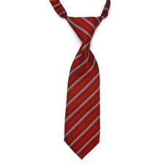 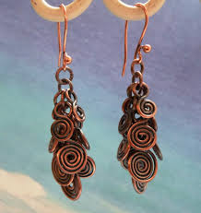 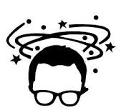 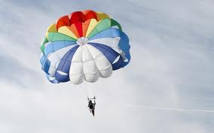

*--------------------------------------------------------------------------------------------*

Good luck