1-……………. name's Yara.

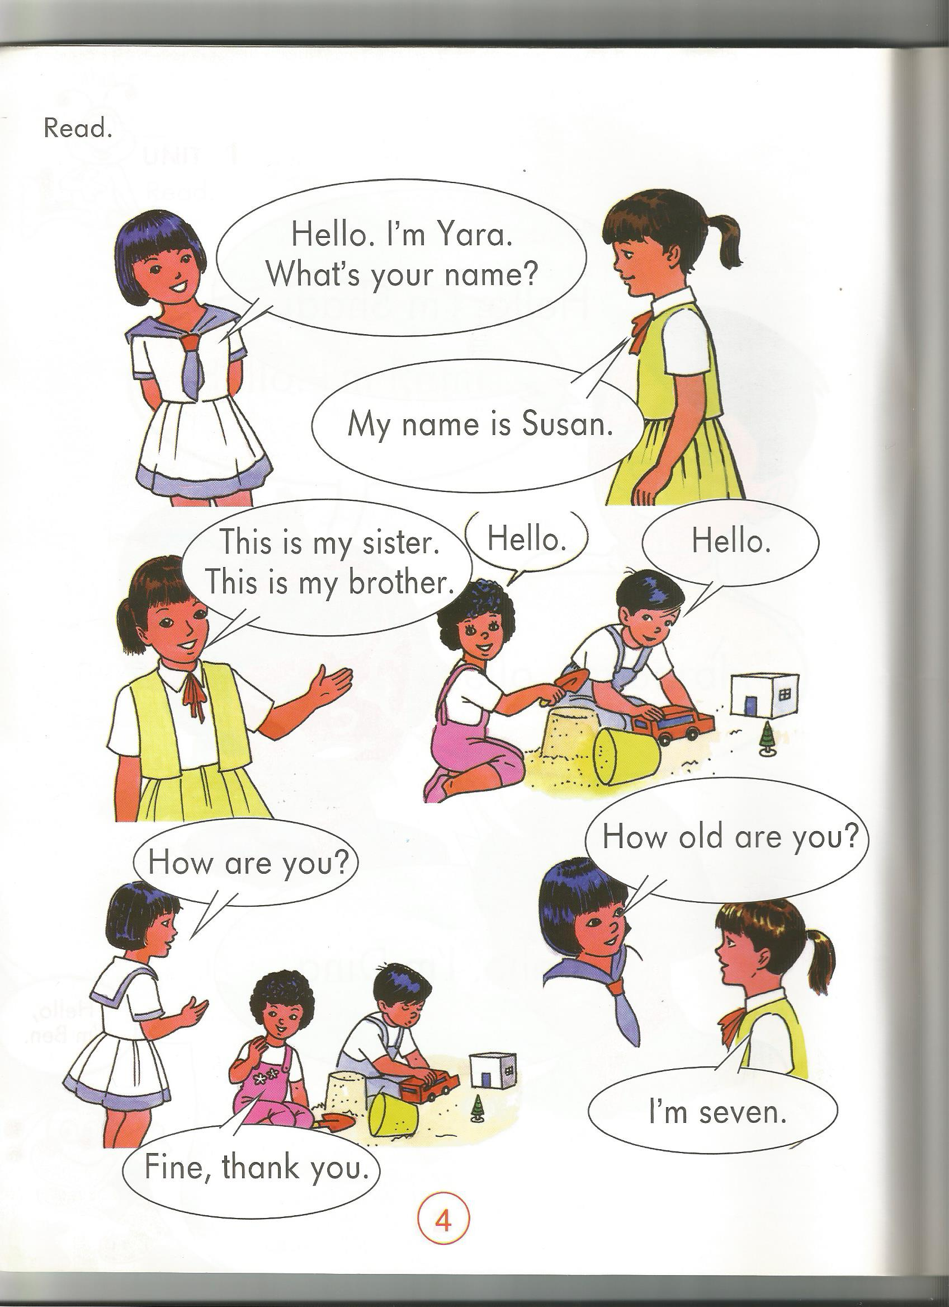

**3**

**2**

2-……………. name's Linda.

**1**

3-……………. name's Tom.