Teacher Frame Revision Unit (4 )

My Name …………………………………………………………………………………………………………………………………………..

Q 1: Write the correct word under each picture :

( housewife - husband - dictionary - paints - married - ruler – raincoat- cloudy - rainy - foggy Sultan - temperature - surgery - medicine - internet )

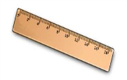



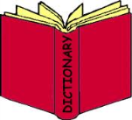 …….. ….….. …..… ……... ……… …….. …….. …….

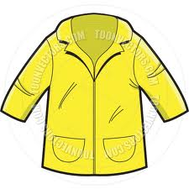

……… ………. ……… ….…. ……… ..…..… ………

Q3: Choose :

1- When ( was – did ) your last trip ? .

2- When ( do – did ) they close the market ?

3- She ( watch – watched ) T.V an hour ago .

4- They ( visit – visited ) her friends yesterday .

5- Layla is ( fast – faster ) than Reema .

6-My bag is ( colourfuler – more colourful ) than Nada's .

7- Jack is ( interested – interesting ) in French .

8- Reading stories is ( exciting – excited ) !