**Write the suitable word under each picture:-**



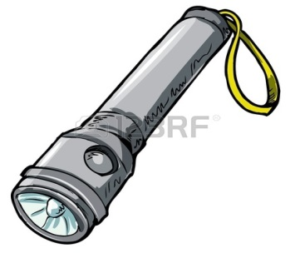

**Write the suitable word under each picture:-**

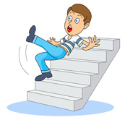

**Change the sentence in to negative:-**

a) Nina slept late on Wednesday .

…………………………………………………………………………………………………………….

b) Rakan found a mouse in his house .

…………………………………………………………………………………………………………….

c) Ibrahim drove omar to hospital .

…………………………………………………………………………………………………………….

**Write the suitable word under each picture:-**

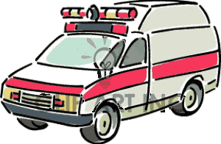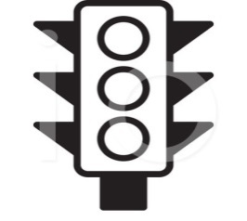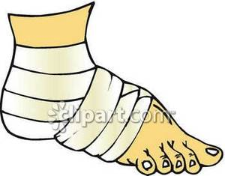

**Fill the missing words in the followings:-**

1- It takes you to the hospital……………………………………

2- The driver of a car hold ……………………………..

3- Sometimes they are red and sometimes green…………………………………………

4- You can use this when you cut yourself………………………………………………