**My clothes**

Name:...................................................... class:5 /..................

What he is wearing ?



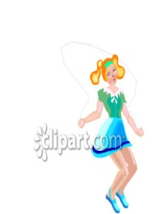What she is wearing ?

*********************************************************

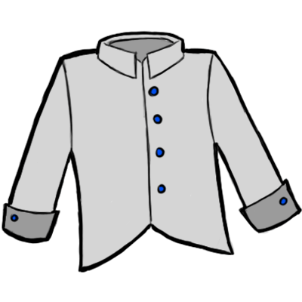**Use ( This /That / These/ Those ), ( a / an ) to form sentences as the example :**

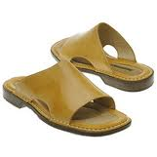This is a blue shirt .

....................................................

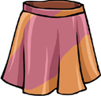

..........................................................

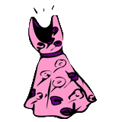

.........................................................

...........................................................

\*\*\*\*\*\*\*\*\*\*\*\*\*\*\*\*\*\*\*\*\*\*\*\*\*\*\*\*\*\*\*\*\*\*\*\*\*\*\*\*\*\*\*\*\*\*\*\*\*\*\*\*\*\*\*\*\*\***Use ( a / an ) to fill the space:**

1-.......abaya 2- ......... orange shirt 3- ...... green coat 4-......red dress. 5- ...... skirt. 6-........black abaya.