**1) Answer the following questions:-**

What is your name?

...........................................................................................................

**2) Match the following words with the pictures;-**

a- Math b- chemistry c- PE d-history

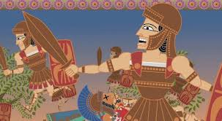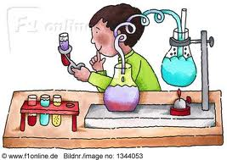

---------------------- ---------------------- ----------------------

**3 ) A - Complete the sentences with the words in the box :**

**fast – desert - newsagent's - florist's**

-Harry saw a Camel in the ……………….

-When something isn't slow , it's …………………..

-You can buy magazine and news paper at the……………………………….

-You can buy flowers at the ………………………………………………..

**B - Circle the correct words :**

1-The underground is always ( crowded - Cheap ) in the morning.

2- The ( trip - voyage ) to the museum was interesting .

3-Last year , a shark ( worried - attacked ) me when I was on holiday.

4-I like this armchair . it is very ( annoying - comfortable ) .

**4) A - Complete with the present simple :**

1- Sara ………………….(cook) the lunch every weekend .

2-The boys …………………(play) football every Friday .

**B - Complete with the past progressive of the verb in brackets:**

1- I ……………………….. { download } some information from the internet .

2-We …………………………… { watch }football on TV.

0

**C - Rewrite the sentence using the adverbs of frequency in brackets :**

Frank watches TV after work ( never )

…………………………………………………………………………………………

**D - Make yes / No Questions**

Tom is going out with his friends.

-----------------------------------------------

**5) A - Make sentence by putting the words in the correct order:**

plays / William / every day / table tennis .

…………………………………………………………………………

**B - Complete the sentence with can , could , can't or couldn't**

1 - How many language …………………… you speak ?.

2- I ……………………….. swim three years ago . but now I can .

**C - Choose the correct answer:**

1-Can I have …………..milk in my tea please?

a)no b)any c)some

2 -The children found …………… kitten in the garden .

a)any b)no c)some

3-While Vicky …………….her room , she found 20$

a)Was tidying b)tidied

4 -The boys were swimming in the river when their friends ………….

a)arrived b) were arriving

**D - Complete the sentence with the correct form of the adjectives in brackets:**

1-I think it's the ………………… ( cold ) day of the week today .

2-My uncle's car is ………………………….. ( modern ) than my dad's .

3-Who's the …………………………….. (famous ) scientist of our century?