**The Kingdom of Saudi Arabia**

**Ministry Of Education.**

**Name:……………. Class:……………**

**الصف الثاني المتوسط**

**English Written Mid Term Exam 1433-1434 H- 2nd Term -**

**10**

***Q1. Use the following words:***



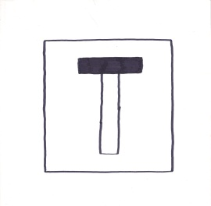

1. Dead end 2. Happy 3. Fountain

Q2:Answer the questions:

a. Who was your friend ?

{ My friend was Ahmad - My friend is Ahmad - My friend was 14}

b. Do you live in a city ?

{ I live in a city - I don't live a city - No, I don't .}

Q3: Choose ;

1. He ( was – were – is ) here yesterday .

2. ( Were - Was ) he here ?

3. Ali is ( tall- taller –tallest ) .

4. ( Was- Were ) you in Makkah last week ?

5. The school is ( in – over – on ) the left .