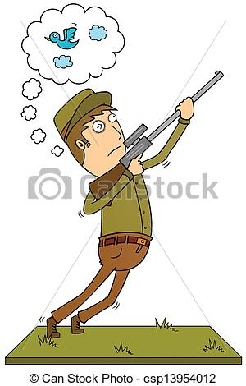**Write the suitable word under each picture**

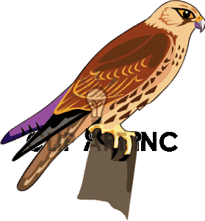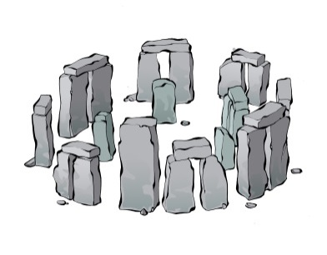

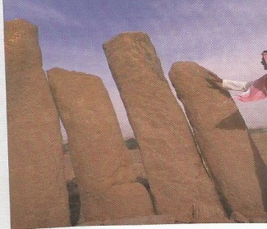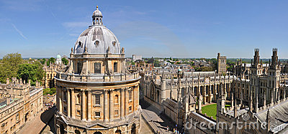

- **Choose the correct form**

a) They are going to the park to ( **play –playing – played**) ).

b) They are going to the supermarket to ( **buy – bought- buying** ) juice.

**Give the opposite:-**

Put on ≠ …………………….. pick up ≠ …………………………. Turn on ≠ ……………………….

Turn up ≠ ……………………. Come in ≠ …………………………

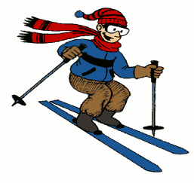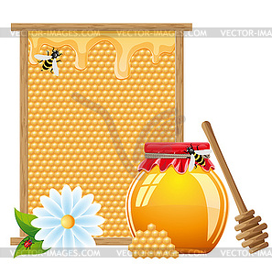**Write the suitable word under each picture**

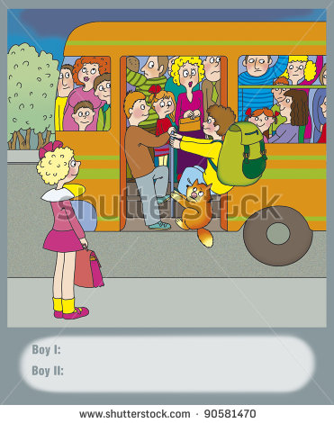



**Choose the correct verb:-**

1- He ( **write –wrote –written** ) his homework last night. .

2-She ( **speak –spoke – spoken**) loudly in the last lesson .

**Do as shown between brackets:-**

**( Change into negative)** 1- He wrote his homework last night.

………..……………………………………………………………….

2- She came **to my house** last week.  **( ask with {where})** .

……………………………………………………………………………….

3-They drove very fast **yesterday. ( ask with {when})** .

………………………………………………………………………